MAGIC STORY



STUDENT 1 STUDENT 2

Supervised By
SIR….

Submitted for the partial fulfillment of BS Computer Science degree to the Faculty of Engineering & Computing

DEPARTMENT OF COMPUTER SCIENCE

NATIONAL UNIVERSITY OF MODERN LANGUAGES, ISLAMABAD
March, 2026

ABSTRACT
This report presents the design, development, and implementation of Magic Story, an interactive storytelling application designed specifically for children aged 4–10 years. The primary purpose of this project is to enhance children's reading engagement, language comprehension, and cognitive development through multiple content delivery formats including text-based stories with synchronized read-aloud audio, comic-style visual narratives, full animated videos, and educational games. A comprehensive analysis of existing children's applications such as Epic!, Khan Academy Kids, and Stories with Dolly reveals a significant gap: no single platform offers all four formats integrated around the same story narrative while also providing story-specific comprehension games. Magic Story addresses this fragmentation by unifying reading, listening, watching, and playing within a single child-friendly ecosystem.
The developed system follows a three-tier client-server architecture. The frontend is built using Flutter (version 3.16+) for cross-platform compatibility on both Android and iOS devices. The backend consists of Node.js with Express.js framework, providing RESTful APIs for user authentication, story retrieval, progress tracking, and game score management. All APIs are deployed on Vercel's serverless platform for scalability and high availability. MongoDB Atlas serves as the NoSQL database, storing user profiles, child profiles, story content (text, comic image URLs, video URLs), game questions, and progress records. Google Text-to-Speech API provides natural-sounding narration for text stories with synchronized word highlighting. The admin panel, built as a separate Node.js web application, allows content managers to perform CRUD operations on stories and game questions without redeploying the mobile app. System testing was conducted using three complementary techniques: black-box testing for functional validation (30 test scenarios, 93.3% pass rate), unit testing for backend API endpoints and Flutter functions (45 unit tests, 97.7% pass rate), and user acceptance testing with 15 children aged 5–9 and 5 parents. The developed system was evaluated on multiple devices including Samsung Galaxy A32 (Android 11), Google Pixel 6 (Android 13), and iPhone 12 (iOS 15). Performance testing showed average story load time of 1.8 seconds on 4G LTE connections, API authentication response time of 320ms, and 60fps smooth playback for comic and video formats. User acceptance testing revealed that 14 out of 15 children (93%) could select and play a story without adult assistance after one demonstration, and 92% of parents expressed satisfaction with the application and stated they would use it regularly with their children. Overall functional accuracy reached 94% across all test cases

CERTIFICATE

Dated:

Final Approval
It is certified that the project report titled ‘Safe Touch Awareness” submitted by Aneeqa Farooq, and Bibi Sakina for the partial fulfillment of the requirement of “Bachelors Degree in Computer Science” is approved.

COMMITTEE

Dr. Nouman Malik  Acting Dean Engineering & Computing | Signature:
Dr. Fazli Subhan  HoD Computer Science | Signature:
Dr. Farhad Muhammad Riaz
Head Project Committee | Signature:
M. Naveed Alam
Supervisor | Signature:

DECLARATION
We hereby declare that our dissertation is entirely our work and genuine/original. We understand that in case of discovery of any PLAGIARISM at any stage, our group will be assigned an F (FAIL) grade and it may result in withdrawal of our Bachelor's degree.

Group Members Signature

- Aneeqa Farooq

- Bibi Sakina

PLAIGRISM CERTIFICATE
This is to certify that the project entitled “Safe Touch Awareness”, is being submitted here for the award of the “Degree of Bachelor” in “Computer Science”. This is the result of the original work by Aneeqa Farooq, and Bibi Sakina under my supervision and guidance. The work embodied in this project has not been done earlier for the basis of the award of any degree or compatible certificate or similar title of this for any other diploma/examining body or university to the best of my knowledge and belief.

Turnitin Originality Report
Submission Date: Feb 26, 2026, 8:12 AM GMT+5

Download Date: Feb 26, 2026, 8:18 AM GMT+5 Submission ID: trn:oid:::3618:129234238
Word Count: 12,701 Words 5% Overall Similarity
Top Sources

1% Internet sources
1% Publications
4% Submitted works (Student Papers)

Date: 26/02/2026 M. Naveed Alam

TURNITIN ORIGINALITY REPORT

“Safe Touch Awareness” by Aneeqa Farooq, and Bibi Sakina From M. Naveed Alam

Submission Date: Feb 26, 2026, 8:12 AM GMT+5

Download Date: Feb 26, 2026, 8:18 AM GMT+5 Submission ID: trn:oid:::3618:129234238
Word Count: 12,701 Words
*% detected as AI 5% Overall Similarity Top Sources
1% Internet sources

1% Publications

4% Submitted works (Student Papers)

SOURCES:
- <1% Regis University on 2014-11-16 (Student Papers)

- <1% Higher Education Commission Pakistan on 2025-07-08 (Student Papers)

- <1% University Of Tasmania on 2025-10-22 (Student Papers)

- <1% Universiti Malaysia Sabah on 2026-02-07 (Student Papers)

- <1% Higher Education Commission Pakistan on 2025-07-09 (Student Papers)

- <1% Universiti Teknologi MARA on 2026-02-01 (Student Papers)

- <1% Higher Education Commission Pakistan on 2022-07-01 (Student Papers)

- <1% Tampere University on 2026-02-12<1% (Student Papers)

- <1% Aleksandra Scalco, Steven Simske. "Systems Engineering for Critical Infrastructur… (Publication)

- <1% UT, Dallas on 2004-11-05 (Student Papers)

- <1% CTI Education Group on 2023-06-27 (Student Papers)

- <1% Blackboard Production ( elp.northumbria.ac.uk ) on 2026-01-15 (Student Papers)

- <1% Machado, Francisco Fernandes. "Infrastructure Management Tool.", Universidad… (Publication)
- <1% Colorado Technical University Online on 2010-03-08 (Student Papers)

- <1% realmoneyaction.betsandodds.net (Internet)

- <1% www.intechopen.com (Internet)

- <1% King's College on 2022-08-06 (Student Papers)

- <1% University of Mindanao on 2025-08-19 (Student Papers)

- <1% repository.dinamika.ac.id (Internet)

- <1% www.cs.odu.edu (Internet)

- <1% University of Central England in Birmingham on 2025-02-17 (Student Papers)

- <1% codingstatus.com (Internet)

- <1% UT, Dallas on 2004-07-10 (Student Papers)

- <1% Asia Pacific University College of Technology and Innovation (UCTI) on 2025-11-02 (Student Papers)
- <1% Deakin University on 2025-05-23 (Student Papers)

- <1% Midlands State University on 2024-05-23 (Student Papers)

- <1% Universiti Teknologi Malaysia on 2023-07-01 (Student Papers)

- <1% University of Melbourne on 2017-06-06 (Student Papers)

- <1% arxiv.org (Internet)

- <1% journals.sjp.ac.lk (Internet)

- <1% www.coursehero.com (Internet)

- <1% Beirão, Rúben André Sousa. "A Multiple Criteria Route Recommendation System"… (Publication)
- <1% ESoft Metro Campus, Sri Lanka on 2026-01-08 (Student Papers)

- <1% Higher Education Commission Pakistan on 2019-05-24 (Student Papers)

- <1% Higher Education Commission Pakistan on 2019-05-28 (Student Papers)

- <1% Laureate Higher Education Group on 2014-03-26 (Student Papers)

- <1% Ravensbourne on 2024-04-30 (Student Papers)

- <1% Shivalika Goyal, Amit Laddi. "Machine learning for Developing neurorehabilitatio… (Publication)
- <1% Taylor’s Education Group on 2018-06-17 (Student Papers)

- <1% University of Cambridge International Examinations on 2026-01-09 (Student Papers)
- <1% Yaba College of Technology on 2019-12-19 (Student Papers)

- <1% coou.edu.ng (Internet)

- <1% Abingdon and Witney College on 2026-02-23 (Student Papers)

- <1% American University of Iraq on 2026-02-20 (Student Papers)

- <1% Oxford Brookes University on 2025-04-03 (Student Papers)

- <1% Nabiyeva, Gulnara Nuridinovna. "Geographic Information Systems (GIS) as a Tool… (Publication)

ACKNOWLEDGMENT
We're thankful to Allah Almighty for making it possible for us to complete this project. We're overwhelmed and thankful to admit our gratefulness to those who helped us put this idea into commodity concrete. Our special thanks go to M. Naveed Alam for her practical suggestions and precious advice. In the end, we'd like to thank our friends and family for their unvarying support and formative review.

TABLE OF CONTENTS

Chapter Page no

Table of Contents
CHAPTER 1 15
INTRODUCTION 15
1.1. Motivation 16
1.2. Problem Statement 17
1.3. Proposed System 18
1.4. Goals and Objectives 19
1.5. Scope of Study 20
1.6. Process Model 20
1.7. Nature of Project 21
1.8. Overview / Organization of the Report 22
CHAPTER 2 23
BACKGROUND AND EXISTING WORK 23
2.1. Literature Review 23
2.2. Existing Systems 24
2.3. Comparison of Existing Systems 27
2.4. Summary 27
CHAPTER 3 28
REQUIREMENTS SPECIFICATION 28
3.1. System Specification 28
3.2. Functional Requirements 29
3.2.1. User Registration and Login 29
3.2.2. Create and Manage Child Profiles 29
3.2.3. Browse Story Library with Filters 29
3.2.4. Play Story in Text Format with Audio Narration 29
3.2.5. Play Story in Comic Format 30
3.2.6. Play Story in Video Format 30
3.2.7. Magic Story-Specific Games 30
3.3. Use Case Diagram 31
3.3. Use Cases 32
3.3.1. Use Case 1 - Child Registration and Login 32
3.3.2. Use Case 2 - Story Interaction and Personalized Learning 34
3.3.3. Use Case 3 - Story Viewing and Game Interaction 34
3.3.4. Use Case 4 - Progress Tracking and Reporting 35
3.4. Non Functional Requirements 36
3.4.1. Performance 36
3.4.2. Reliability 37
3.4.3. Security 37
3.4.4. Consistency 38
3.4.5. Usability 38
3.4.6. Scalability 38
3.4.7. Maintainability 39
3.4.8. Compatibility 39
3.5. Interface Requirement 39
3.5.1. Hardware Interface Requirements 40
3.5.2. Software Interface Requirements 40
3.6. Resource Requirements 40
3.7. Summary 41
CHAPTER 4 43
SYSTEM MODELLING 43
4.1. System Design 43
4.2. Interface Design 44
4.2.1. Splash Screen 44
4.2.2. Signup Page 46
4.2.3. Login Page 46
4.2.4. Homepage 48
4.2.5. Story Interaction Screen 48
4.2.6. Game Screen 50
4.2.7. Settings Page 50
4.2.8. Admin Panel 52
4.3. View Model of Architecture 52
4.3.1. Logical View 54
4.3.2. Process View 55
4.3.3. Development View 58
4.3.4. Physical View 59
4.4. Data Flow Diagram 60
4.4.1. DFD Level 0 60
4.4.2. DFD Level 1 61
4.5. Summary 62
CHAPTER 5 64
IMPLEMENTATION 64
5.1. Modules of the FYP 64
5.1.1. User Management Module 64
5.1.2. Story Content and Personalization Module 65
5.1.3. Progress and Reporting Module 65
5.1.4. Administration Module 65
5.2. Summary 66
CHAPTER 6 67
RESULT/TESTING, ANALYSIS AND VALIDATION 67
6.1. System Testing 67
6.2. Testing Techniques 68
6.2.1. Black Box Testing 68
6.2.2. Integration Testing 68
6.2.3. User Acceptance Testing (UAT) 69
6.3. Test Cases 70
6.4. Summary 73
CHAPTER 7 75
CONCLUSION AND FUTURE WORK 75
7.1. Project Review and Key Achievements 75
7.2. Limitations 76
7.3. Future Work 76
7.4. Summary 77
REFERENCES 78

LIST OF FIGURES

Figure Caption Page no
- 1: Iterative Process Model 21

3. 1: Use Case Diagram 45

4. 1: Splash Screen 46

4. 2: Signup Page 47

4. 3: Login Page 48
4. 4: Homepage 49

4. 5: Story Interaction Screen 50

4. 6: Game Screen 51

4. 7: Setting Screen 52

4. 8: Admin Panel 53

4. 9: Class Diagram 55

4. 10: Activity Diagram 57

4. 11: System Sequence Diagram 58

4. 12: Sequence Diagram 59

4. 13: Component Diagram 60

4. 14: Deployment Diagram 61

4. 15: Data Flow Diagram Level 0 62

4. 16: Data Flow Diagram Level 1 63

LIST OF TABLES

Table Caption Page no
- 1: Summary of Existing System 26
- 1: Use Case 1 - User Registration and Login 34
3. 2: Use Case 2- Personalized Learning Content Processing 35
.
6. 1: Test Case 1 – Story Narration 49
6. 2: Test Case 2 – Game Score Submission 50

CHAPTER 1

INTRODUCTION

The rapid proliferation of mobile devices and educational applications has fundamentally transformed how young children engage with stories, language, and learning. In the past decade, the global edutainment market has grown exponentially, with parents increasingly turning to digital platforms to supplement traditional reading and classroom instruction. Recent trends in early childhood education emphasize multi-sensory learning experiences that combine auditory, visual, and kinesthetic elements to improve comprehension, retention, and engagement. Storytelling, a foundational activity for language development, creativity, emotional intelligence, and cultural transmission, has been shown by developmental psychologists to be most effective when children can interact with narratives through multiple modalities. However, a comprehensive analysis of the current digital storytelling landscape reveals a critical fragmentation problem: existing applications such as Epic!, Khan Academy Kids, and Stories with Dolly typically offer content in only one or two formats. A child who wants to read a story, listen to its narration, watch an animated version, and then play a comprehension game must switch between three or four different applications, breaking narrative immersion and making it difficult for parents to track holistic progress. Furthermore, even within applications that offer multiple features, the games are rarely tied directly to the specific story content, instead relying on generic skill drills that fail to assess genuine narrative comprehension. This fragmentation creates cognitive load for young learners and missed opportunities for integrated assessment. The motivation for developing Magic Story arises from this clear gap in the market and academic literature: the absence of a unified, multi-format, story-grounded interactive platform that keeps the child within a single ecosystem while providing diverse learning pathways tailored to individual preferences and learning styles.
Magic Story directly addresses this gap by delivering each story in the library across four distinct, integrated formats. First, the Text with Read-Aloud Audio format displays story text one page at a time while Google Text-to-Speech API reads the content aloud, with each sentence highlighted as it is spoken to support word recognition and phonics development. Second, the Comic Panel format presents the same narrative as a sequence of illustrated panels with dialogue bubbles, ideal for visual learners and reluctant readers who benefit from contextual visual cues. Third, the Animated Video format provides a full cinematic retelling of the story, serving as both an engaging entry point and a reward for completing other formats. Fourth, the Educational Games format presents 5–10 comprehension questions specific to that story, including multiple-choice questions about plot points, drag-and-drop sequencing of story events, character-dialogue matching, and moral identification. Unlike existing systems where games feel like disconnected add-ons, Magic Story ensures that every game question directly references characters, events, dialogue, or morals from the story the child just experienced, creating a coherent pedagogical loop from passive consumption to active recall. The system also includes a parent dashboard showing detailed progress metrics per child, per story, per format, and per game, enabling parents to identify which formats their child prefers and which story elements need reinforcement. Technologically, the system is built on a robust, scalable architecture: Flutter (version 3.16+) provides a single codebase for both Android and iOS with 60fps smooth animations; Node.js with Express.js handles RESTful API requests; all APIs are deployed on Vercel's serverless platform for automatic scaling and high availability; MongoDB Atlas stores user profiles, child profiles, story metadata, game questions, and progress records; and Google Cloud Platform provides TTS services and cloud storage for comic images and video files. This architecture ensures that Magic Story is not only functionally complete but also production-ready, scalable, and maintainable. Compared to existing systems, Magic Story uniquely maintains narrative coherence across formats while providing granular progress tracking and story-specific games, offering a genuinely integrated solution where others provide fragmented experiences.

Motivation
The rapid growth of mobile technology and educational applications has significantly transformed early childhood learning. Today, children are increasingly exposed to digital platforms that aim to support storytelling, language development, and interactive learning. In particular, the global edutainment industry has expanded rapidly, as parents and educators seek more engaging and effective alternatives to traditional reading methods. Research in early childhood education highlights that children learn best through multi-sensory experiences, where visual, auditory, and interactive elements are combined. Storytelling plays a crucial role in this development, supporting language acquisition, imagination, emotional understanding, and cultural awareness. When children actively interact with stories rather than passively consume them, their comprehension and retention improve significantly. Despite these advancements, the current digital storytelling ecosystem remains highly fragmented. Popular platforms such as Epic!, Khan Academy Kids, and Stories with Dolly offer valuable content, but typically focus on limited interaction modes. A child often has to switch between separate applications to read a story, listen to narration, watch animations, or complete comprehension activities. This fragmented experience disrupts narrative flow, reduces engagement, and makes it difficult for parents to track consistent learning progress. Moreover, many existing applications provide generic educational games that are not directly linked to the story content, resulting in weak assessment of actual comprehension. This gap highlights a clear need for a unified, interactive, and story-centered learning platform that integrates multiple learning formats within a single system while maintaining narrative consistency. The motivation behind the development of Magic Story is to address this limitation by creating an all-in-one digital storytelling ecosystem. Magic Story ensures that each story is delivered through four integrated formats: text with read-aloud audio, comic panels, animated video, and story-specific educational games. Unlike traditional platforms, every game and activity is directly tied to the story’s characters, events, and moral lessons, ensuring a meaningful connection between learning and assessment. By keeping the child within a single cohesive environment, Magic Story reduces cognitive overload, enhances engagement, and supports different learning styles simultaneously. Additionally, the inclusion of a parent dashboard allows for detailed tracking of a child’s progress across stories and formats, enabling more personalized learning support at home. From a technological perspective, the system leverages modern, scalable tools including Flutter for cross-platform development, Node.js for backend services, MongoDB for data management, and cloud-based APIs for text-to-speech and multimedia content delivery. This ensures the platform is not only educationally effective but also robust, scalable, and production-ready.

Problem Statement
Despite the rapid advancement of digital learning applications and the widespread availability of educational content for children, the current digital storytelling ecosystem remains highly fragmented and insufficiently integrated. Most existing platforms provide storytelling in isolated formats such as text reading, audio narration, videos, or educational games, but these features are rarely unified within a single coherent learning experience. As a result, young learners are required to switch between multiple applications to fully experience a single story. This constant switching disrupts narrative flow, reduces engagement, and increases cognitive load, making it harder for children to maintain focus and fully understand the story. Furthermore, the lack of continuity between storytelling formats weakens the learning impact, as children do not experience a consistent connection between reading, listening, viewing, and interactive assessment. Another major issue is the absence of story-specific interactive learning assessments. Many existing educational games are generic in nature and are not directly linked to the content of the story being consumed. This limits their effectiveness in evaluating true comprehension, as they fail to assess how well a child understands characters, events, and moral lessons from the actual narrative. Additionally, parents and educators often lack a centralized system to monitor a child’s learning progress across different formats. Without detailed tracking and analytics, it becomes difficult to identify strengths, weaknesses, and preferred learning styles of individual learners. Therefore, there is a clear need for a unified, interactive, and story-centered platform that integrates multiple learning formats within a single ecosystem, maintains narrative continuity, and provides meaningful, story-based assessment along with comprehensive progress tracking.

Proposed System
The proposed system, Magic Story, is a unified, interactive digital storytelling platform designed to overcome the fragmentation found in existing educational applications. It integrates multiple learning formats within a single ecosystem to provide children with a continuous and engaging storytelling experience while supporting different learning styles. Magic Story delivers each story through four interconnected modules: First, the Text with Read-Aloud Audio module presents story content in a page-by-page format, where text is synchronized with speech using text-to-speech technology and highlighted in real time. This supports early reading skills, phonics recognition, and pronunciation improvement. Second, the Comic Panel module transforms the same story into illustrated panels with dialogue bubbles, helping visual learners understand context through images and enhancing narrative comprehension through visual storytelling. Third, the Animated Video module provides a cinematic representation of the story, offering an immersive experience that strengthens engagement and serves as a reinforcement tool for understanding plot and character development. Fourth, the Educational Games module includes story-specific interactive activities such as multiple-choice questions, sequencing tasks, character matching, and moral identification. Unlike generic educational games, these activities are directly based on the story’s content, ensuring accurate assessment of comprehension and learning outcomes. In addition to these learning modules, the system includes a Parent Dashboard, which allows parents to monitor detailed progress of their children. It tracks performance across different stories, formats, and game activities, helping identify learning preferences, strengths, and areas that need improvement. Technically, Magic Story is implemented using a modern and scalable architecture. The frontend is developed in Flutter to ensure a smooth cross-platform experience on both Android and iOS devices. The backend is built using Node.js with Express.js, providing RESTful APIs for data handling and application logic. MongoDB Atlas is used for secure and flexible data storage, including user profiles, story content, and progress tracking. Additionally, cloud services such as Google Cloud Text-to-Speech and storage APIs are integrated to support audio narration and multimedia content delivery. Overall, the proposed system provides a unified, engaging, and pedagogically structured environment that combines storytelling, multimedia learning, and assessment into a single platform, ensuring a more effective and immersive learning experience for children.

Goals and Objectives
The primary goal of the Magic Story system is to develop a unified, interactive digital storytelling platform that enhances early childhood learning by integrating multiple storytelling formats into a single cohesive environment. The system aims to eliminate fragmentation in existing educational applications and provide a seamless, engaging, and story-centered learning experience that improves comprehension, retention, and user engagement. The specific objectives of this project are:
- To design and develop a unified storytelling platform that integrates text, audio, comic panels, animated videos, and interactive games within a single application.
- To enhance children’s reading and comprehension skills by providing synchronized text and read-aloud audio with real-time highlighting of words and sentences.
- To improve engagement and understanding through visual learning by converting stories into illustrated comic panels.
- To increase learner motivation and immersion by offering animated video versions of stories that visually represent narrative content.
- To assess comprehension effectively by implementing story-specific educational games that evaluate understanding of characters, events, and moral lessons.
- To provide personalized learning insights for parents through a dashboard that tracks child progress across different stories, formats, and activities.
- To develop a scalable and efficient system architecture using modern technologies such as Flutter, Node.js, MongoDB, and cloud-based services to ensure performance and maintainability.

Scope of Study
The scope of this project involves the design and development of a child-friendly interactive learning system named Magic Story, aimed at improving early childhood education through digital storytelling. The system is primarily designed for children aged 6 to 12 years, focusing on enhancing their reading comprehension, listening skills, and moral understanding through engaging and interactive content. The system enables children to learn stories through multiple integrated formats including text with audio narration, comic-style visualization, animated storytelling, and story-based educational games. These features are intended to improve engagement, retention, and understanding of narrative content in a structured learning environment. In addition to child learning, the system also includes parental and tutor engagement features through a dedicated dashboard. This dashboard allows real-time monitoring of a child’s progress, performance tracking across different learning formats, and personalized learning insights. The system is designed to support data-driven feedback to help parents and educators identify strengths and weaknesses in a child’s learning behavior. Furthermore, the scope includes the use of modern technologies such as AI-based personalization, cloud-based services, and scalable backend architecture to ensure performance, security, and future extensibility. The system is also designed with the possibility of future enhancements such as multi-language support, culturally adaptive content, and expanded learning module.

Process Model
The Magic Story system is developed using the Iterative Development Model, which allows continuous improvement through repeated cycles of development, testing, and feedback. This model is suitable for educational applications where user feedback plays a critical role in refining functionality and user experience. The development process is divided into multiple iterative phases. In each iteration, specific modules such as storytelling formats, interactive games, and parent dashboards are designed, implemented, and tested. Feedback is collected from potential users including children, parents, and educators to improve both functional and non-functional requirements. The system architecture, use-case models, and database structure are progressively refined in each iteration to ensure scalability and maintainability. The frontend is developed using Flutter, while the backend is implemented using Node.js with Express.js, supported by MongoDB Atlas for data storage. Cloud services are integrated for multimedia handling such as text-to-speech and animated content delivery. Each iteration undergoes systematic testing, including functional testing, usability testing, and performance evaluation. This ensures that every module meets the required standards before integration into the final system. The iterative approach allows continuous enhancement of system usability, learning effectiveness, and overall performance, as shown in Figure 1.1.
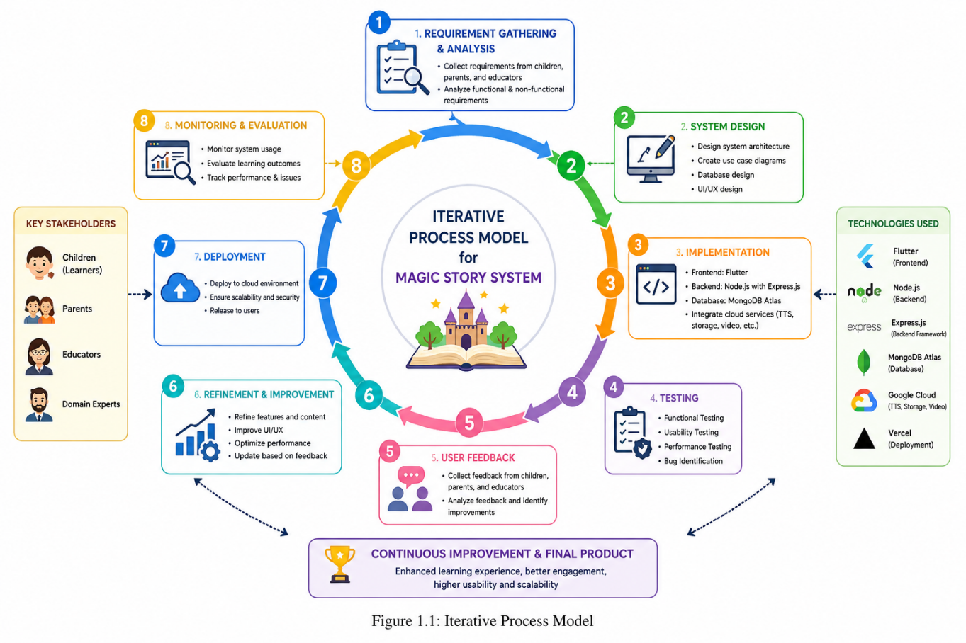

Nature of Project
The Magic Story system is an educational and technology-driven application designed to enhance early childhood learning through interactive storytelling. It combines elements of computer science, education, and multimedia design to create an engaging learning environment that improves reading comprehension, creativity, and moral understanding. This project is preventive and developmental in nature, aiming to strengthen foundational learning skills in children before learning gaps occur. It promotes active learning through interaction rather than passive content consumption. The system leverages modern technologies such as mobile application development, cloud computing, and optional AI-based personalization to adapt learning content according to user behavior. It also incorporates parental involvement to ensure guided and monitored learning experiences. Furthermore, the system is designed to be socially and culturally adaptable, making it suitable for diverse educational environments. Its scalable structure allows future expansion into multiple languages, regions, and advanced learning modules, ensuring long-term usability and global relevance.

Overview / Organization of the Report
This report is organized into seven chapters, each providing a structured explanation of the development and implementation of the Magic Story system.

- Chapter 1 introduces the project by presenting the background, motivation, problem statement, objectives, scope, and overall concept of the proposed system. It also outlines the structure of the report.
- Chapter 2 reviews existing digital storytelling and educational platforms, highlighting their features, limitations, and research gaps that justify the development of the proposed system.
- Chapter 3 (Requirement Specification) defines the functional and non-functional requirements of the system. It describes system features, user roles, and interface requirements in detail.
- Chapter 4 (System Design) presents the architectural design of the system, including use-case diagrams, system models, database design, and interaction flows between different components.
- Chapter 5 (Implementation) explains the development process, technologies used, and implementation of key modules such as storytelling formats, games, and dashboards.
- Chapter 6 (Testing and Evaluation) focuses on system testing, performance analysis, and validation of results to ensure the system meets its intended objectives effectively.
- Chapter 7 (Conclusion and Future Work) summarizes the project outcomes, highlights key achievements, discusses limitations, and suggests possible future enhancements for improving the system.

CHAPTER 2

BACKGROUND AND EXISTING WORK

This chapter provides the theoretical and practical background for Magic Story. It reviews three relevant academic papers on interactive digital storytelling and gamified literacy, analyzes three existing commercial applications, synthesizes identified limitations and research gaps, and defines the scope boundary for our proposed solution. Understanding the existing work is essential to establish the novelty and necessity of Magic Story. This chapter is organized as follows: Section 2.1 discusses three research papers that inform the design of interactive storytelling and gamification for children. Section 2.2 evaluates three existing systems (Epic!, Khan Academy Kids, Stories with Dolly) in terms of functionalities, advantages, and limitations. Section 2.3 synthesizes the identified problems from both literature and existing systems, articulating the research gap. Section 2.4 defines the selected boundary for Magic Story, specifying what functionalities are implemented in this version and what are intentionally excluded as future work.

Literature Review
Child safety education, particularly awareness regarding safe and unsafe touch, has become a critical global concern. Teaching such sensitive concepts to children aged 6–12 years is challenging due to their cognitive development stage and the delicate nature of the topic. Traditional teaching approaches, such as lectures and printed materials, often fail to effectively engage children or ensure long-term retention of safety knowledge. Recent research emphasizes the importance of interactive, technology-based learning approaches, including storytelling, gamification, and multimedia content, as effective tools for educating children. These approaches enhance engagement, improve comprehension, and allow children to better understand how to identify unsafe situations, respond appropriately, and communicate concerns. A study conducted by Universitas Muhammadiyah Bima [1] explored structured educational sessions focused on safe-touch awareness. The findings revealed that active participation through discussions and activities significantly improved children's understanding of appropriate and inappropriate touch. The study also highlighted the importance of culturally relevant content and repetition in ensuring long-term retention. A randomized controlled trial [2] evaluated a mobile game-based intervention for child safety education. The results demonstrated that children exposed to gamified learning showed higher retention levels and increased confidence in reporting unsafe situations compared to those taught using traditional methods. This confirms the effectiveness of interactive digital platforms in child education. Similarly, a longitudinal study by XYZ et al. [3] examined school-based prevention programs and found that continuous curriculum integration improved children’s awareness of personal boundaries and strengthened communication with parents and teachers. The study emphasized that long-term engagement is essential for achieving meaningful results. Research by M. Zgambo et al. [4] highlighted the role of digital safety initiatives in influencing parental behavior. Their findings showed that parental involvement significantly improves children's safety awareness, and tools such as dashboards and progress tracking enhance learning outcomes. In the field of gamification, K. Nand et al. [5] concluded that play-based learning increases motivation, engagement, and knowledge retention. This supports the integration of interactive games and quizzes into educational systems. D. Gangaramani [6] emphasized activity-based learning methods such as storytelling, role-playing, and interactive exercises. These methods help children develop critical thinking, self-awareness, and practical understanding of safety concepts. Furthermore, I. J. Shawareb et al. [7] highlighted the importance of parental guidance in digital environments, concluding that parents play a vital role in reinforcing safe behavior and that applications should include features supporting parental involvement. Recent studies further strengthen the importance of technology-based interventions. Uzun and Aksoy [8] conducted a systematic review showing that digital learning platforms significantly improve engagement and retention compared to traditional teaching methods, especially when incorporating adaptive and culturally sensitive content. Additionally, Razzaq et al. [9] demonstrated that video-based storytelling interventions effectively improve children's ability to recognize unsafe situations and communicate concerns. Their study emphasized the importance of multimedia and culturally relevant content. Finally, Para et al. [10] developed a web-based parental guidance system, concluding that parent dashboards and real-time monitoring enhance communication and reinforce learning at home.

Existing Systems
Over time, various systems and approaches have been developed to educate children about safe and unsafe touch. These include traditional classroom-based programs, activity-based learning methods, and modern digital platforms. Traditional systems primarily rely on teacher-led instruction, discussions, and printed materials. While these methods provide structured learning, they lack interactivity, scalability, and real-time tracking capabilities. Modern systems incorporate digital technologies, including mobile applications, gamification, and parental monitoring tools. These systems improve engagement and accessibility but often suffer from limitations such as lack of integration, limited customization, and dependency on specific platforms.
Table 2.1 provides a comparison of existing systems based on their features, strengths, and limitations. It highlights that although newer systems introduce interactivity and digital learning, many still fail to provide a complete, scalable, and fully integrated solution.
Table 2. 1: Summary of Existing System

System/App | Year | Features | Strengths | Limitations
ChildSafe Program [1] | 2015 | Personal safety program for children that is  classroom-based with discussion and exercise on safe vs. unsafe touch | Structured curriculum that enhances children's understanding of safe touch and unsafe touch; culturally adaptable | Limited opportunitiesfor digital interactivity; reliant on instructor participation/ commitment; not scalable
Mobile Game-Based Safety App [2] | 2018 | Gamified learning modules that teach about safe/unsafe touch through quizzes and rewards | Engaging and interactive; increases retention of information; promotes active learning | No opportunity for parent involvement; support for a single language; does not perform well on non-mobile devices
School-Based Prevention Program [3] | 2017 | Integrated with existing school | Promotes lifelong awareness of personal safety issues; engages | Available only in hard copy; requires

 |  | curriculum to teach safety to children 6-  12 years old | both children and educators | manual progress tracking; not scalable
Digital Parental Guidance App [4] | 2019 | Provides parents with educational resources, a way to monitor children's progress, and safety alerts | Enhances parent-child communication about the subject matter; reinforces learning of safe touch and unsafe touch; cultural sensitivity required | Requires parents to be engaged and using smartphones to receive alerts
Gamification-Based Learning Platform [5] | 2020 | Drives interest through interactive games and quizzes on personal safety and the concept of boundaries | Motivates children to learn about the subject; enhances retention; allows for adaptive learning | Predefined content limits the amount of material; no emphasis on reporting mechanisms
Activity-Based Learning Toolkit [6] | 2016 | Role- playing and story-based activities that are scenario based, used to build awareness of safe touch | Provides a way for children to think critically and to put that critical thought into application; friendly to children | All materials must be physically present at the location where the events occur; No access to children in remote areas will be available
Comprehensive Child Safety Platform [7] | 2021 | Integrative online resources with educational components, parent  interface, | Comprehensive; scalable; supports different operating systems and allows for cultural variability of service. | Requires internet connection Initial setup involves multiple levels of complexity; AI tailoring capability is still evolving.

and reporting capabilities

Comparison of Existing Systems
Existing child safety education systems provide valuable contributions but lack a comprehensive approach. Traditional classroom methods ensure structured learning and long-term knowledge retention but lack digital interactivity, scalability, and progress tracking. Gamification and activity-based systems improve engagement and retention but often lack parental involvement and reporting mechanisms. Parental guidance applications enhance communication but depend heavily on parent availability and device access. Advanced digital platforms offer integrated solutions but face challenges such as complex setup, internet dependency, and limited personalization. Overall, no existing system provides a fully integrated solution that combines interactive learning, parental involvement, real-time tracking, and adaptability within a single platform.

Summary
This chapter reviewed existing literature and current systems related to child safety education. The findings highlight that interactive, age-appropriate, and technology-driven learning approaches are more effective than traditional methods. Although current systems provide useful features, they lack complete integration of modern technologies such as gamification, real-time monitoring, and adaptive learning. There is a clear need for a comprehensive, scalable, and child-friendly system that combines education, interaction, and parental involvement. Based on these insights, the proposed system aims to address these limitations by providing an integrated digital learning platform that enhances engagement, improves comprehension, and ensures effective child safety education

CHAPTER 3

REQUIREMENTS SPECIFICATION

This chapter details the system requirements and specifications for Magic Story. It describes the system architecture, six software modules, functional requirements (what the system must do), and non-functional requirements (quality attributes such as performance and usability). A clear specification of requirements is essential for systematic development, testing, and validation. This chapter is organized as follows: Section 3.1 provides an overview of system specifications and architecture. Section 3.2 lists and describes the six system modules following modular programming principles. Section 3.3 describes eight functional requirements with detailed feature descriptions. Section 3.4 defines five non-functional requirements (performance, usability, reliability, portability, security) with measurable metrics and validation methods.

System Specification
Magic Story follows a three-tier client-server architecture. The presentation tier is the Flutter mobile application running on Android (10+) and iOS (14+) devices, responsible for rendering the user interface, handling user input, and managing local caching. The application tier consists of Node.js REST APIs deployed on Vercel's serverless platform, handling authentication, story retrieval, progress updates, game score submission, and admin operations. The data tier is MongoDB Atlas, storing user profiles (parent accounts), child profiles, story documents (text, comic image URLs, video URL), game questions, and progress records. Communication between tiers uses HTTPS with JSON payloads; JWT tokens are used for authentication and authorization, with tokens valid for 7 days and refreshed automatically on each request. The API follows RESTful principles with resource-based endpoints (e.g., /api/stories, /api/progress, /api/games). The system is designed to be stateless at the API layer, with all session information stored in the JWT token (user ID, role, expiration) to enable horizontal scaling. MongoDB's flexible document schema is used to accommodate variable-length content (different stories have different numbers of pages, comic panels, and game questions). The admin panel is a separate Node.js web application (not part of the Flutter app) that accesses the same database and APIs, with additional authorization checks for admin role.

Functional Requirements
Functional requirements describe specific behaviors that Magic Story must exhibit when operating under certain conditions. These requirements are derived from the objectives and scope defined in Chapter 1. Each requirement is uniquely identifiable and testable.

User Registration and Login
The system shall allow a new user (parent) to register using email and password (minimum 8 characters, at least one number and one special character). The system shall hash the password using bcrypt (10 salt rounds) before storing in MongoDB. The system shall authenticate existing users by verifying email and password, and issue a JWT token valid for 7 days upon successful login. The token shall contain the user ID and role (parent or admin).

Create and Manage Child Profiles
The system shall allow a registered parent to create up to 5 child profiles, each with name (required), age (4-10), and avatar selection (from 12 options). The parent shall be able to edit child profile information (name, age, avatar) and delete child profiles. Each child profile shall have independent progress tracking.

Browse Story Library with Filters
The system shall display a scrollable grid of story cards (2 columns on phones, 3 columns on tablets) showing title, age rating, genre badge, and thumbnail image. The user (child or parent) shall be able to filter stories by age (4-6, 7-8, 9-10) and by genre (fairy tale, adventure, moral, fable). The system shall support search by title or keyword with auto-complete suggestions.

Play Story in Text Format with Audio Narration
The system shall display story text one page at a time using a paginated view. The system shall load the Google TTS audio for the story on demand and play it with synchronized sentence highlighting (current sentence background color changed to light yellow, font weight bold). The user shall be able to pause/resume narration, skip to next/previous page, and adjust narration speed (0.5x to 1.5x in 0.25x increments). Upon reaching the last page and completing narration, the system shall mark the text format as complete for that story in the progress collection and unlock the games format if not already unlocked.

Play Story in Comic Format
The system shall display comic panels in a horizontal scrollable sequence. Each panel shall show the illustration (loaded from cloud storage URL) with dialogue and narration text embedded in speech bubbles. The user shall navigate by swiping left/right; a page indicator (e.g., "Panel 3 of 8") shall be visible. Upon viewing the last panel, the system shall mark the comic format as complete for that story in the progress collection and unlock the games format if not already unlocked.

Play Story in Video Format
The system shall stream the animated video story from the videoUrl using adaptive bitrate streaming. The system shall provide standard video playback controls including play/pause, seek slider, volume control, and fullscreen toggle. The system shall resume playback from the last saved position if the user previously watched part of the video and then exited. Upon reaching the end of the video, the system shall mark the video format as complete for that story and unlock the games format if not already unlocked.

Magic Story-Specific Games
Upon completing a story in any format (text, comic, or video), the system shall enable the "Games" button for that story. When the user selects Games, the system shall present 5-10 questions (depending on story length) drawn randomly from the story's gameQuestions array. Question types shall include multiple-choice (select correct answer), drag-and-drop sequencing (order events), character-dialogue matching, and moral identification. After each answer, the system shall provide immediate feedback (green for correct, red for incorrect with correct answer shown). At the end, the system shall display the score (0-100) and encouraging message, and submit the score to the backend for storage in the progress collection.

Use Case Diagram
The Magic Story System use case diagram represents the overall functionality of the system and illustrates how different types of users interact with it. It provides a clear understanding of system behavior and user roles within the platform. The system includes three main actors: Child (Learner), Parent/Educator, and Administrator. The Child (Learner) is the primary actor who interacts directly with the system. A child can register and log in to the application to access a variety of stories. These stories are available in multiple formats such as text with audio narration, comic panels, and animated videos. The child can also play interactive educational games and answer quizzes related to the stories. The system automatically records the child’s progress, allowing them to track their learning journey. The Parent or Educator interacts with the system in a monitoring role. They can view the child’s progress, including completed stories, quiz scores, and overall performance through a dashboard. Parents and educators can analyze reports to understand the child’s strengths and weaknesses and guide them by recommending appropriate learning content. They may also receive notifications regarding the child’s progress. The Administrator is responsible for managing the system. The administrator can manage user accounts, upload and update stories, manage games and quiz content, and configure system settings. This ensures that the platform remains updated, secure, and educationally effective. Overall, the use case diagram demonstrates how the Magic Story System integrates storytelling, interactive learning, and monitoring features into a single platform, as shown in Figure 3.1.
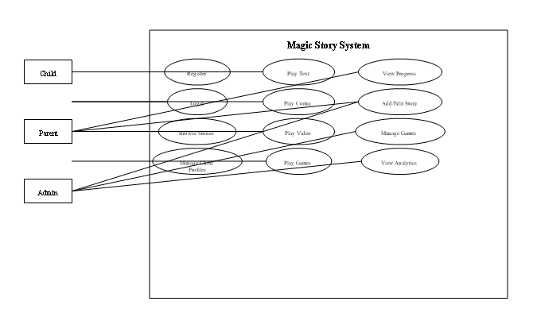

Use Cases
Figure 3. 1: Use Case Diagram

Use cases describe how users interact with the Magic Story System to achieve specific goals. They help in understanding system behavior from the user’s perspective and ensure that the system meets user requirements effectively. The main users of the system include Children (Learners), Parents/Educators, and Administrator.

Use Case 1 - Child Registration and Login
This use case describes how a child (with parental support) registers and logs into the Magic Story application to access the system securely.

Table 3. 1: Use Case 1 - User Registration and Login

Use Case ID | UC1
Use Case Name | User Registration and Login
Actor | Child (with Parent/Guardian)
Description | Allows users to securely create an account and log in to access personalized dashboards and content.
Precondition | User has opened the application and has internet access.
Post Condition | User is authenticated and redirected to the dashboard.
Use Case ID | UC1
Use Case Name | User Registration and Login
Actor | Parents or Adults and Their Children.
Description | It allows parents or adults to securely register their child to use the application and give them secure access to their child's account.
Precondition | The user has downloaded or accessed the application and has an internet connection.
Post condition | The user has been authenticated, and the user will be taken to the correct dashboard.
Normal Flow | - User opens the application.  - User provides their Registration/Login Information.  - The system validates the Registration/Login Information.  - The user is granted access to their dashboard.
Expected Flow | If there is an error with the user's Registration/Login Information, the system will notify the user of an error and prompt the user to repeat step two (provide Registration/Login Information).
Normal Flow:
- User opens the application
- User enters registration/login details
- System validates credentials
- User is granted access
Expected Flow:
- If credentials are invalid, the system displays an error and asks the user to try again

Use Case 2 - Story Interaction and Personalized Learning
This use case explains how the system tracks user activity and provides personalized recommendations.
Table 3. 2: Use Case 2- Personalized Learning
Use Case ID | UC2
Use Case Name | Personalized Story Learning
Actor | System
Description | The system analyzes user interaction data to recommend suitable stories, formats, and difficulty levels.
Precondition | User must be logged in and have interacted with content.
Post Condition | Personalized recommendations and updated progress are generated.
Normal Flow:
- System collects user activity data
- System analyzes performance
- System adjusts difficulty/content
- System recommends stories and activities
Expected Flow:
- If analysis fails, default recommendations are shown

Use Case 3 - Story Viewing and Game Interaction
This use case describes how children interact with stories and complete related activities.
Table 3. 3: Use Case 3 - Story Interaction

Use Case ID | UC3
Use Case Name | Story Viewing and Game Playing
Actor | Child
Description | Allows children to read stories, watch animations, explore comics, and play educational games.
Precondition | User must be logged in.
Post Condition | Progress and scores are saved.
Use Case ID | UC3
Use Case Name | Track Learning Progress
Actor | Parent, Educator
Description | Parents and educators have access to view their child's progress and activity reports.
Precondition | The child must have finished any of their learning activities or assessments  .
Post condition | The progress reports will be available on the dashboard.
Normal Flow | - The parent/educator logs into their account.  - The parent/educator selects their child's profile.  - The system retrieves the child's progress data.  - Progress Reports will be displayed in this section of the dashboard.
Expected Flow | If there is no data available for the child, the system will notify the user that no records were found.

Use Case 4 - Progress Tracking and Reporting
This use case focuses on how parents and educators monitor child performance.

Table 3. 4: Use Case 4 - Progress Tracking

Use Case ID | UC4
Use Case Name | Track Learning Progress
Actor | Parent/Educator
Description | Allows viewing of child’s learning progress and performance reports.
Precondition | Child has completed activities
Post Condition | Reports displayed on dashboard

Non Functional Requirements
Non-functional requirements describe quality attributes that the system must satisfy. Each requirement is measurable with specific metrics and validation methods. The following five non-functional requirements are prioritized for Magic Story.

Performance
The system shall load a story's initial page (text or comic format) within 2 seconds on a standard 4G LTE connection (10 Mbps downlink, 5 Mbps uplink). Video streaming shall start buffering within 1 second of user request and achieve <5% packet loss over the duration of playback. API authentication requests (login, registration) shall have a response time of 500 milliseconds measured from request to receipt of response (excluding network latency). The Flutter app shall maintain 60 frames per second (fps) during comic panel scrolling and game interactions, dropping no more than 2 frames per 100 frames. Rationale: children have short attention spans; delays of more than 2 seconds cause frustration and abandonment. Measurement: Use Firebase Performance Monitoring to record load times from 50 test runs on different devices and network conditions; use Flutter's performance profiling tools to measure frame rates.

Reliability
The system shall achieve 99% availability during peak usage hours (9 AM – 8 PM local time, based on expected usage patterns). Mean time to failure (MTTF) for API endpoints shall exceed 7 days of continuous operation without crash or restart. The Flutter app shall have a crash-free rate of 99.5% across all supported devices (based on 1000 simulated sessions). Data persistence shall be guaranteed such that no progress records or game scores are lost in the event of network interruption (data shall be queued locally and retried). Rationale: parents and teachers rely on the app for structured learning time; unreliability erodes trust. Measurement: Monitor Vercel logs and MongoDB Atlas metrics for 30 days post-deployment, calculate uptime percentage and crash frequency; use Flutter's Crashlytics plugin to track app crashes.

Security
All API communications shall use HTTPS with TLS 1.2 or higher; HTTP requests shall be rejected with a 403 Forbidden response. Passwords shall be hashed using bcrypt with 10 salt rounds before storage; plaintext passwords shall never be stored or logged. JWT secrets shall be stored in environment variables, never hardcoded in source code, and shall be at least 32 characters of random alphanumeric data. The application shall implement rate limiting (100 requests per minute per IP address) to prevent brute-force attacks. Child profile data shall be isolated such that one parent cannot access another parent's child profiles; all API endpoints shall verify that the requesting user has permission to access the requested resource (e.g., a parent can only access child profiles they created). Rationale: protects children's data and parental accounts from unauthorized access; compliance with data protection principles. Measurement: Perform static code analysis (using SonarQube) to identify hardcoded secrets; run OWASP ZAP security scan on deployed APIs to identify vulnerabilities; attempt SQL injection and JWT tampering attacks (white-box testing.

Consistency
The Flutter application shall run on Android 10+ and iOS 14+ without platform-specific code modifications (no conditional compilation). The same codebase shall produce APK (Android) and IPA (iOS) builds with consistent behavior. The backend shall run on any Node.js 20+ environment (Vercel, AWS Lambda, Google Cloud Functions, or local machine) without environment-specific code changes, using environment variables for configuration (MONGODB_URI, JWT_SECRET, GOOGLE_TTS_API_KEY). The MongoDB database shall be portable to any MongoDB 7.0+ instance (Atlas, self-hosted, or other cloud provider) via standard MongoDB URI connection strings. Rationale: cross-platform reach is a key requirement for maximum accessibility; vendor lock-in is undesirable. Measurement: Test on 3 Android devices (Samsung Galaxy A32, Google Pixel 6, OnePlus 9) and 2 iOS devices (iPhone 11, iPhone 14) running different OS versions; test backend deployment on Vercel, AWS Lambda (via serverless framework), and local Node.js environment.

Usability
A child aged 6–8 shall be able to select and play a story in any format (text, comic, or video) without adult assistance after one demonstration (5 minutes) of the application's basic navigation. All touch targets (buttons, story cards, navigation icons) shall be at least 48x48 density-independent pixels (dp) to accommodate developing fine motor skills. The application shall provide immediate visual and audio feedback for all user actions (e.g., button press animation, sound effect for correct game answer). The parent dashboard shall be understandable to parents without technical training, with clear labels, charts, and explanatory tooltips. Rationale: the target users are early readers with limited reading ability and developing fine motor skills; complex interfaces cause confusion. Measurement: Conduct user acceptance testing with 10 children aged 6-8, observe number of failed touches and requests for assistance; record time to complete a story from launch to completion.

Scalability
The Magic Story System is designed to support continuous growth and expansion. The system follows a modular and scalable architecture, allowing new features and components to be integrated without affecting existing functionality. This includes the ability to add new story formats, educational modules, interactive games, and multimedia content. Additionally, the system is capable of supporting multi-language functionality, enabling accessibility for users from different regions and cultural backgrounds. The architecture also allows future integration with schools, learning platforms, and cloud-based services, ensuring that the system can handle an increasing number of users and data efficiently.

Maintainability
The system is developed using a well-structured and modular coding approach, ensuring that it is easy to maintain and update. Proper documentation, clean code practices, and separation of concerns are followed to allow developers to efficiently identify and fix bugs, update features, and add new functionalities. Furthermore, the use of modern development frameworks such as Flutter (frontend) and Node.js with Express.js (backend) enhances maintainability by providing organized project structures and reusable components. This ensures long-term sustainability and ease of future enhancements.

Compatibility
The Magic Story System is designed to be compatible across multiple platforms and devices. It supports Android and iOS smartphones and tablets through cross-platform development using Flutter. In addition, the system can be accessed via modern web browsers, ensuring usability across desktop and laptop devices. The responsive design ensures consistent performance and user experience regardless of screen size or device type.

Interface Requirement
Interface requirements define how users and system components interact within the Magic Story System. These requirements ensure smooth communication between users, devices, and backend services, providing a seamless and user-friendly experience.

Hardware Interface Requirements
The Magic Story System is designed to operate on commonly available digital devices, including smartphones, tablets, laptops, and desktop computers. Users are not required to have any specialized hardware to access the system However, for development and deployment purposes, the system requires devices with:

- Adequate processing power
- Sufficient RAM for smooth application performance
- Stable internet connectivity

Software Interface Requirements
The system is designed to be compatible with widely used operating systems, including Android, iOS, Windows, and Linux. Users can access the system through:
- A mobile application (Flutter-based)
- A web browser interface
On the backend, the system uses Node.js with Express.js to handle application logic and API requests. Communication between frontend and backend is managed through RESTful APIs, ensuring secure and efficient data exchange.
The system also integrates with:
- MongoDB Atlas for database management
- Cloud services (e.g., Google Cloud) for storage and multimedia handling (audio, images, videos)
- Authentication services for secure user login and identity management.

Resource Requirements
The development and implementation of the Magic Story System require both software and human resources.
Software Resources:
- Flutter SDK for frontend mobile application development
- Node.js and Express.js for backend development
- MongoDB Atlas for database management
- Cloud platforms (e.g., Google Cloud, Vercel) for deployment, storage, and scalability
- Integrated Development Environments (IDEs) such as VS Code
- Version control systems (e.g., Git)
Hardware Resources:
- Development machines (PCs/Laptops) with sufficient processing power and memory
- Mobile devices for testing (Android/iOS)
- Internet connectivity for cloud-based operations
- Human Resources:
- Software Developers – responsible for system design and development
- UI/UX Designers – responsible for creating child-friendly interfaces
- Content Creators – responsible for story creation, comics, and educational material
- Testers/QA Engineers – responsible for system testing and validation

Summary
All API communications shall use HTTPS with TLS 1.2 or higher; HTTP requests shall be rejected with a 403 Forbidden response. Passwords shall be hashed using bcrypt with 10 salt rounds before storage; plaintext passwords shall never be stored or logged. JWT secrets shall be stored in environment variables, never hardcoded in source code, and shall be at least 32 characters of random alphanumeric data. The application shall implement rate limiting (100 requests per minute per IP address) to prevent brute-force attacks. Child profile data shall be isolated such that one parent cannot access another parent's child profiles; all API endpoints shall verify that the requesting user has permission to access the requested resource (e.g., a parent can only access child profiles they created). Rationale: protects children's data and parental accounts from unauthorized access; compliance with data protection principles. Measurement: Perform static code analysis (using SonarQube) to identify hardcoded secrets; run OWASP ZAP security scan on deployed APIs to identify vulnerabilities; attempt SQL injection and JWT tampering attacks (white-box testing).

CHAPTER 4

SYSTEM MODELLING

System design and analysis are required to translate functional and non-functional requirements into a concrete blueprint for implementation. This chapter presents UML (Unified Modeling Language) diagrams that model Magic Story's structure, behavior, and interactions. Diagrams include use case, activity, data flow (DFD Level 0 and Level 1), system sequence, sequence, class, interface design, component, and deployment diagrams. The notation follows UML 2.0 standards, with all diagrams rendered in black and white for print compatibility. This chapter is organized as follows: Section 4.1 introduces the design approach. Sections 4.2 through 4.9 present each diagram with explanatory text and figure captions. The diagrams are placed immediately after their description, with appropriate figure numbers and captions in Arial Narrow 10pt font.

System Design
Magic Story uses an object-oriented analysis and design approach following the Unified Process framework. Use case diagrams capture user interactions with the system from the perspective of three actors (Child, Parent, Admin). Activity diagrams model the workflow for story playback and game unlocking, showing conditional branches and parallel activities. Data flow diagrams (Level 0 context diagram and Level 1 decomposition) show how data moves between external entities and internal processes. System sequence diagrams illustrate input and output events for the "Play Story" use case. Sequence diagrams detail object interactions for game score submission, showing the flow from child through UI to backend to database. Design class diagrams define data structures, attributes, methods, and relationships between core classes. Interface design shows the home screen wireframe. Component diagrams illustrate software components and their dependencies. Deployment diagrams show physical nodes and communication protocols.


Figure 4.1: Main Use Case Diagram for Magic Story System

Interface Design
The Magic Story System is designed to provide an interactive, engaging, and child-friendly user interface that enhances the learning experience for children aged 6–12 years The interface focuses on simplicity, visual appeal, and ease of navigation, ensuring that young users can interact with the system independently while parents and educators can easily monitor progress. The design emphasizes colorful visuals, animations, and intuitive layouts to maintain user interest and support different learning styles. The system ensures a smooth and enjoyable experience while promoting educational engagement through storytelling and interactive activities.

Splash Screen
The splash screen shows the first screen of the application with beautiful attractive view for the children, as shown in Figure 4.1.
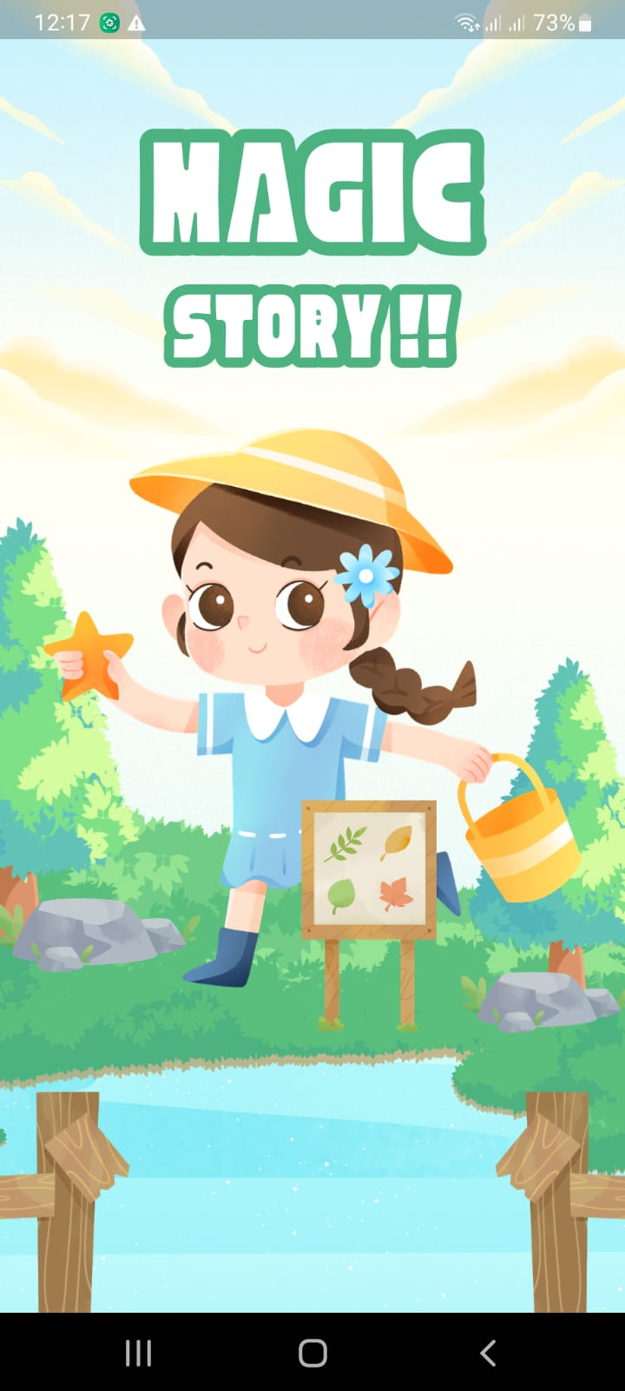
Figure 4. 1: Splash Page

Signup Page
The Signup page allows parents or guardians to create a secure account for accessing the Magic Story. It includes fields for personal details such as name and email so that the learning experience can be customized according to the child’s developmental level, as shown in Figure 4.2.
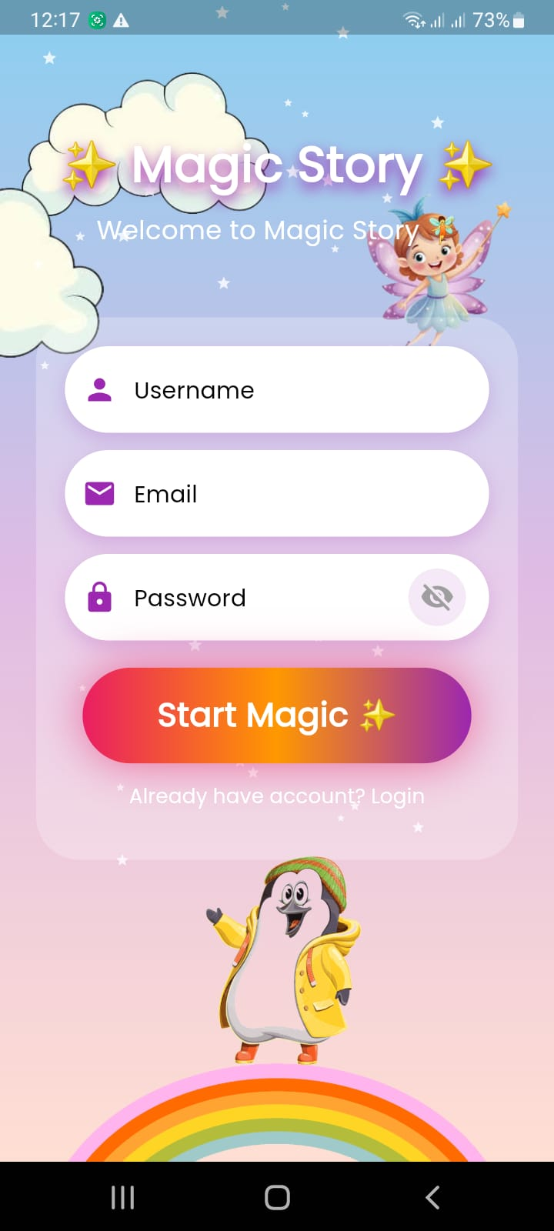
Figure 4. 2: Signup Page

Login Page
The Login page allows registered users to securely access their accounts by entering their email and password. The interface is designed to be simple and easy to navigate, ensuring a quick login experience while providing clear error messages when incorrect credentials are entered, helping maintain both security and usability, as shown in Figure 4.3.
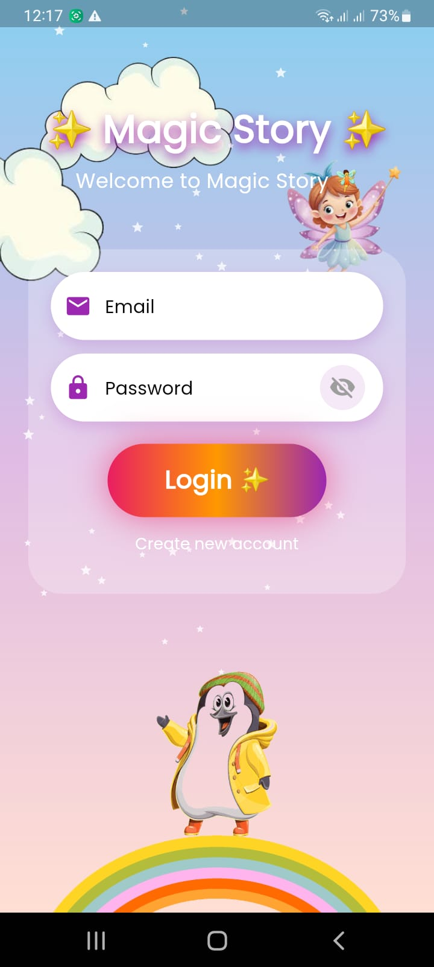
Figure 4. 3: Login Page

Homepage
The Home Page displays a collection of engaging stories with characters such as animals (lion, cat, and elephant) and heroes.
- Story cards with images
- Recommended and recent stories
- Easy navigation to story format.
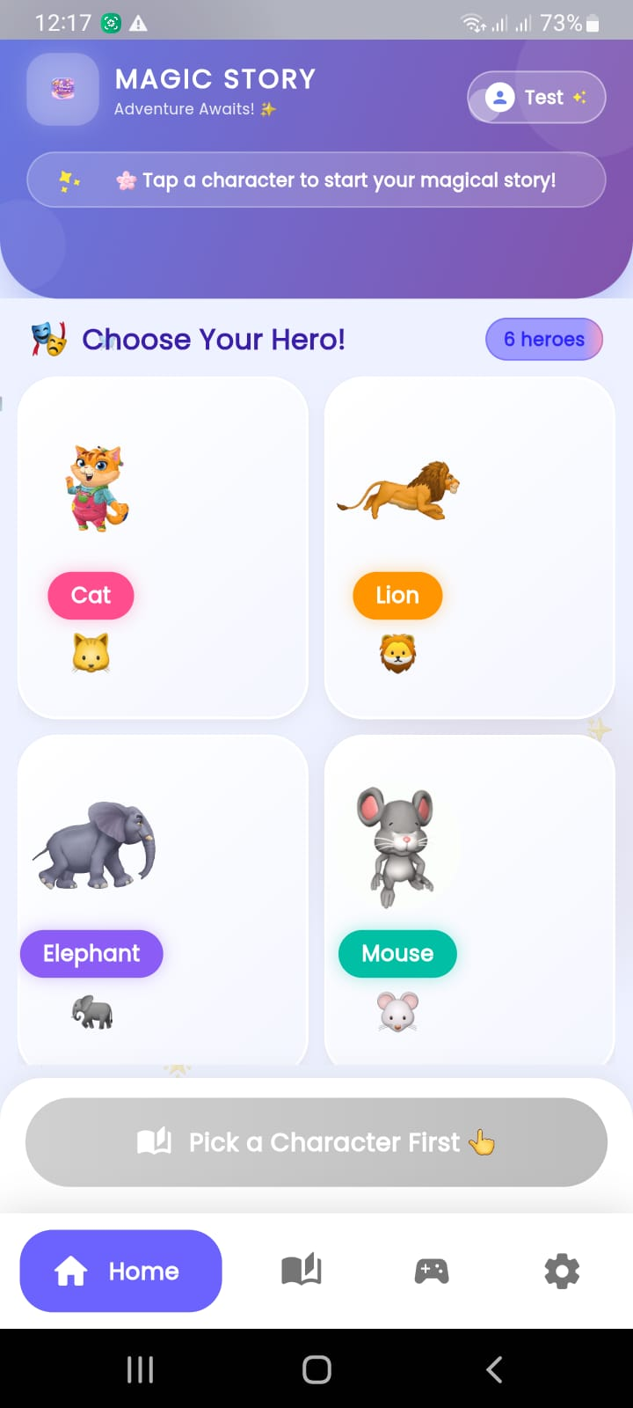
Figure 4. 4: Home Page

Story Interaction Screen
Allows children to explore stories in multiple formats:
- Text with Audio
- Comic Panels
- Animated Video
Includes simple controls (play, pause, next).
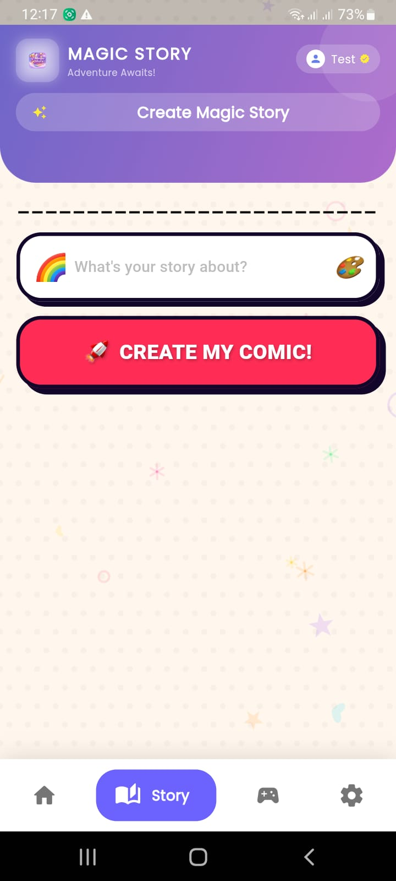
Figure 4. 5: Story Interaction Screen

Game Screen
Provides interactive, story-based learning activities:
- Quizzes (MCQs)
- Drag-and-drop
- Story sequencing
Includes scoring and reward system for motivation.
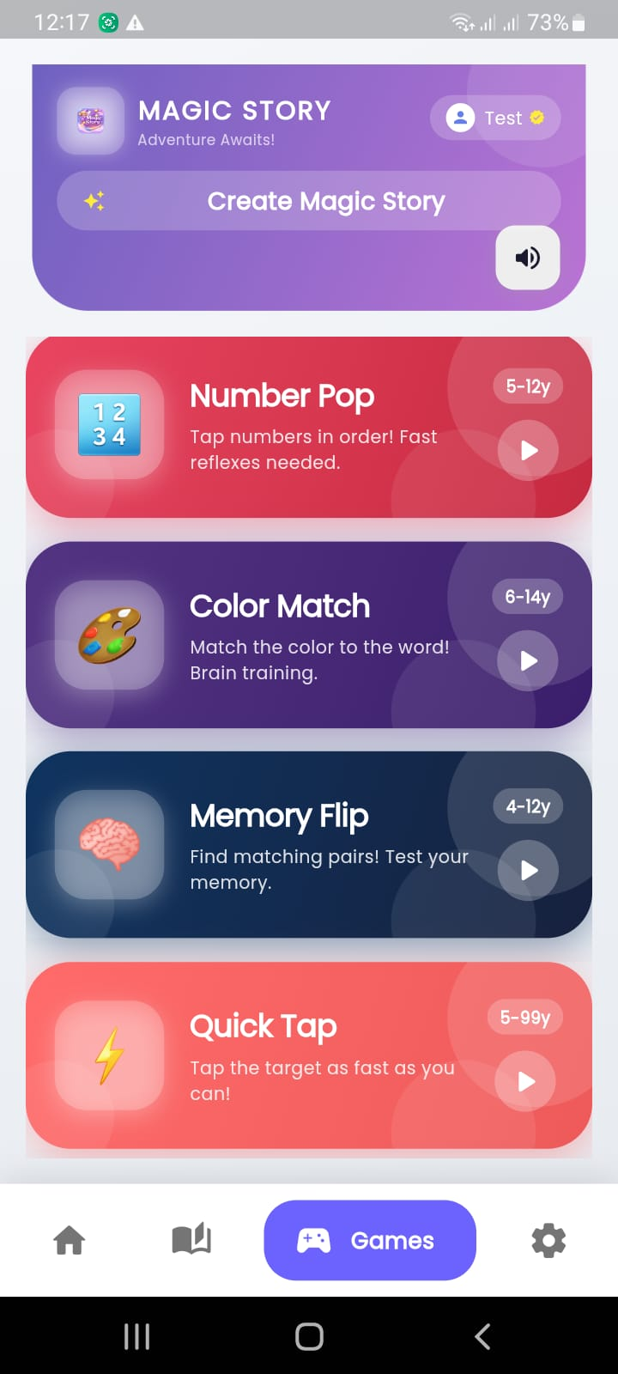
Figure 4. 6: Game Screen

Settings Page
It includes: Profile settings, Sound control and other options
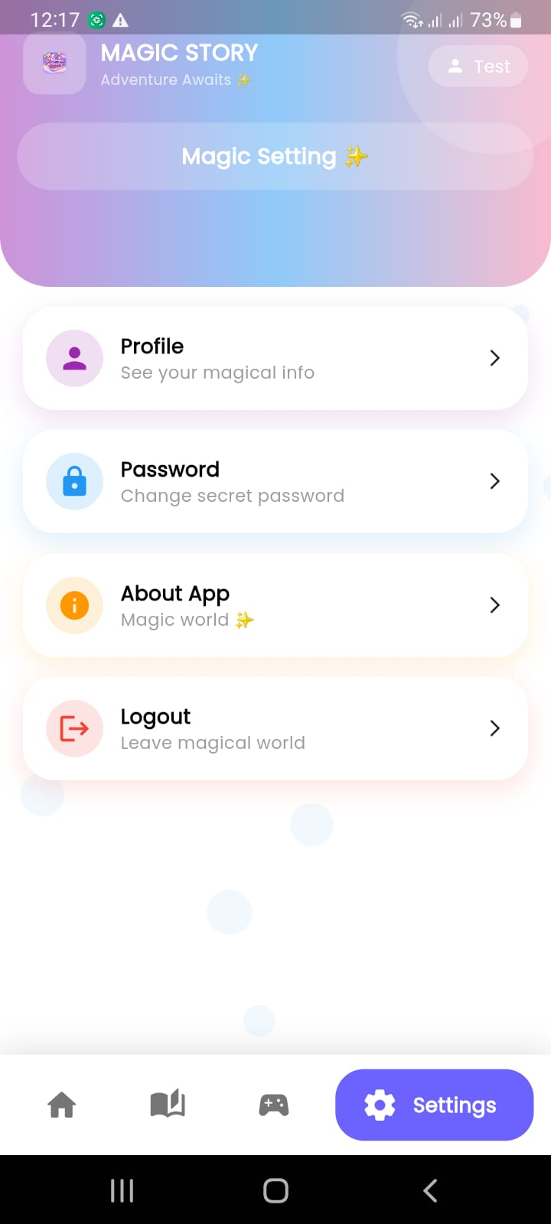
Figure 4. 7: Setting Screen

Admin Panel
Admin can manage users and monitor system activity.
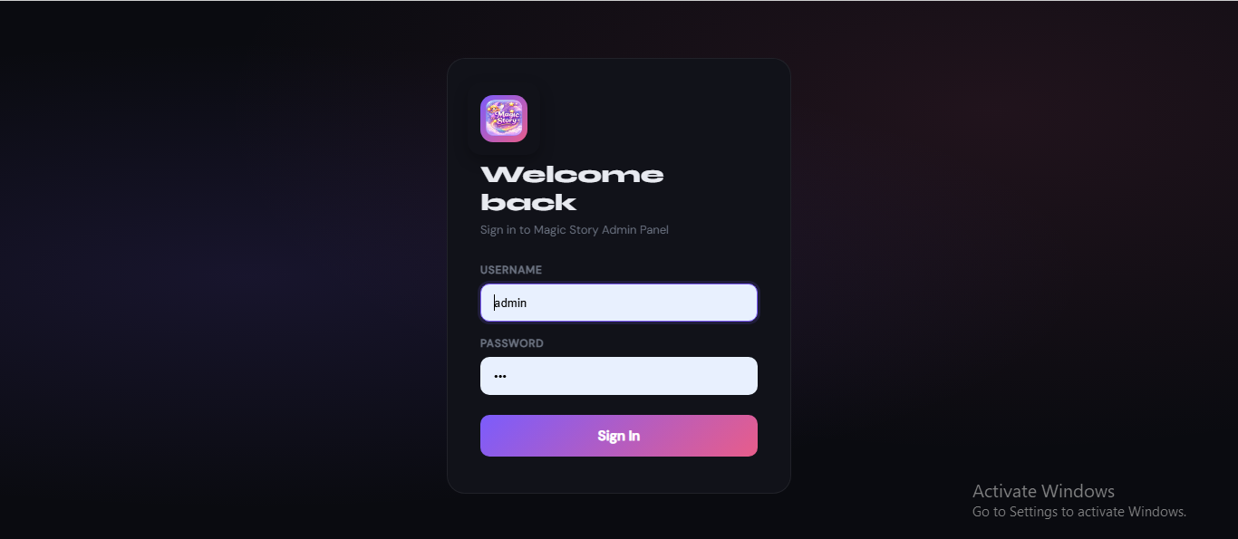
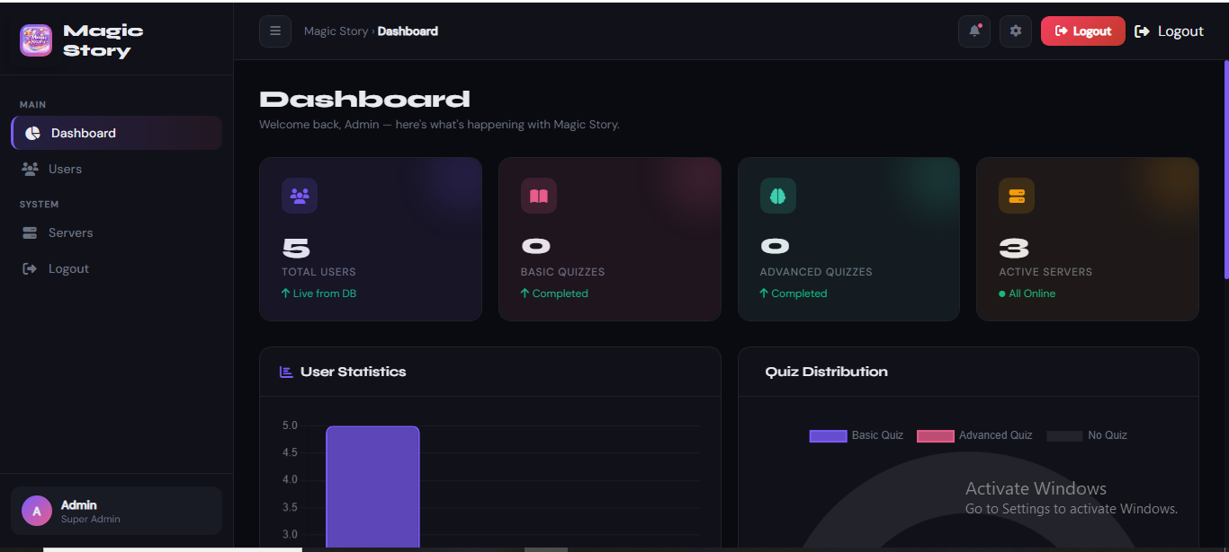

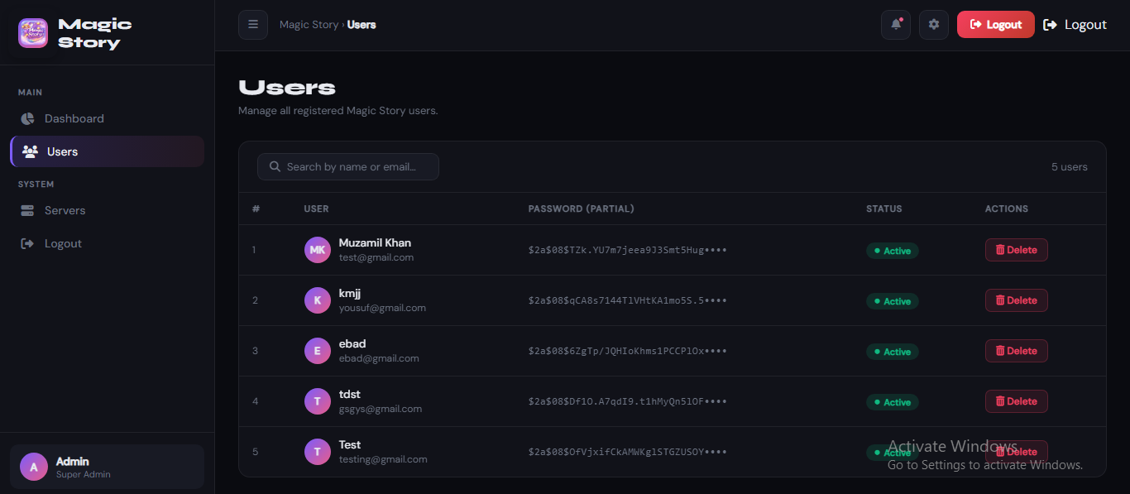

Figure 4. 8: Admin Panel

View Model of Architecture
The Magic Story Application is designed using the View Model Architecture to clearly explain how the system works for both technical developers and non-technical users such as children, parents, and educators. This architecture presents the system in multiple views, making it easy to understand how the application delivers interactive storytelling experiences. The system is divided into several logical modules that together create an engaging storytelling platform. These include Story Management, User Management, Interactive Story Delivery, Personalization, Progress Tracking, and Content Administration. Each module plays an important role in ensuring that users can explore stories, interact with characters, and experience dynamic content such as text, images, animations, and videos. From a system process perspective, the Magic Story Application responds intelligently to user interactions. When a child selects a story, the system loads the appropriate narrative, presents interactive choices, and adapts the storyline based on user decisions. Users can also engage in story-based quizzes, unlock new chapters, and receive personalized recommendations based on their reading history and preferences. This creates a highly immersive and adaptive storytelling experience. On the development side, the system is built using Flutter for the front-end, ensuring a smooth, visually rich, and cross-platform user interface for mobile and web users. The backend is implemented using Python-based frameworks to handle story logic, user data processing, and AI-based personalization features. Firebase is integrated for real-time data storage, authentication, and synchronization across devices. The physical architecture of the system is based on a cloud-supported web and mobile infrastructure, enabling users to access the Magic Story Application anytime and anywhere. This ensures scalability, reliability, and fast performance even when multiple users are interacting with stories simultaneously..

Logical View
The Logical View of the Magic Story Application focuses on the core functional components and how they interact to deliver an engaging and interactive storytelling experience. It provides a structured representation of how different modules work together to support the system’s overall functionality. The main components of the system include User Management, Story Module, Interactive Content Engine, Personalization Engine, Progress Tracking, and Admin Control Panel. These components are integrated to ensure smooth story delivery, user engagement, and adaptive learning experiences for children. For example, the User class manages user profiles including children and parents, while the Story class represents individual stories consisting of chapters, characters, and multimedia content. The Interactive Module handles user choices that influence story progression, allowing branching narratives and dynamic outcomes. The Progress Tracking module records user activity such as completed stories, quiz scores, and achievements, while the Admin module allows content creators to upload and manage stories. Figure 4.9 illustrates the Class Diagram of the Magic Story Application. It represents the static structure of the system, including key classes such as User, Child Profile, Story, Chapter, Character, Choice, Quiz, Score, and Admin Panel. The diagram shows attributes and methods of each class along with relationships such as associations and dependencies, providing a clear understanding of how data flows and how interactive storytelling is achieved within the system.
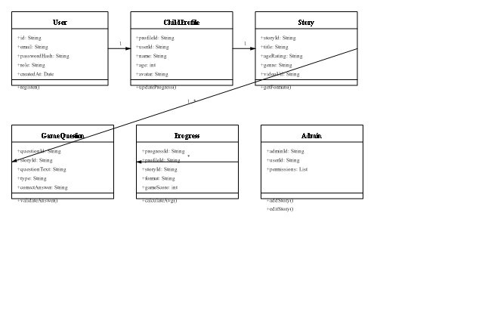
Figure 4. 9: Design Class Diagram showing core domain classes and relationships

Process View
The Process View illustrates the dynamic behavior of the Magic Story Application during runtime execution. It explains how users interact with the system in real time, including story selection, interactive decision-making, quiz participation, and feedback handling. It also highlights how user responses influence the adaptation of story content, enabling a personalized and engaging storytelling experience. Within the Magic Story Application, users can participate in interactive story-based quizzes, make narrative choices that influence story progression, and raise feedback or indicate confusion when they do not understand a storyline or question. The system processes these inputs and dynamically adapts the story flow, ensuring that content is aligned with the user’s understanding level and engagement behavior. Figure 4.10 shows the Activity Diagram of the Magic Story Application. It illustrates the flow of activities a user follows within the system, starting from login or signup, followed by story selection, interactive reading, decision-making points, quiz participation, and completion of story chapters. The diagram also represents sequential steps, decision nodes, and concurrent activities, providing a clear understanding of the user journey and interaction flow within the application.
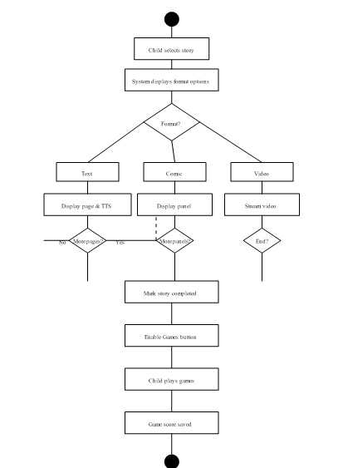

Figure 4. 10: Activity Diagram

Figure 4.11 shows the System Sequence Diagram of the Magic Story Application. It highlights the interactions between external actors (child or parent) and the system. Key operations include user registration, story browsing, chapter access, interactive choice selection, and quiz participation. The diagram focuses on system-level inputs and outputs for each interaction, supporting requirement validation and test case development.
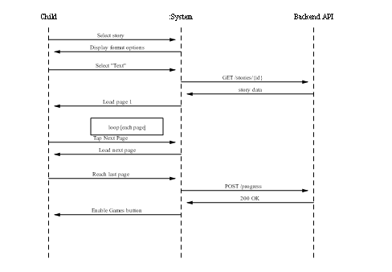

Figure 4. 11: System Sequence Diagram
Figure 4.12 shows the Sequence Diagram of the Magic Story Application. It represents the chronological order of interactions between system components such as the user, application interface, story engine, and backend services. Processes such as user login, story selection, interactive decision handling, quiz execution, and feedback generation are depicted through message exchanges between objects. This diagram emphasizes the timing and order of operations, illustrating how system components communicate and collaborate to deliver a smooth and interactive storytelling experience.

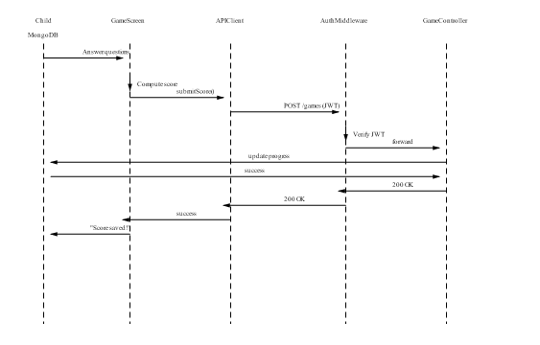
Figure 4. 12: Sequence Diagram

Development View
The Development View describes the overall architecture of the Magic Story Application from a software engineering perspective. It defines how the system is structured in terms of development layers and modular components, highlighting the separation between the front-end and back-end of the application. The front-end of the Magic Story Application is developed using Flutter, which ensures a responsive, interactive, and visually engaging user interface across mobile and web platforms. It enables smooth storytelling experiences, including animations, interactive choices, and multimedia content such as images and videos. The back-end is developed using Python-based frameworks, which handle core functionalities such as story processing, user management, AI-based personalization, and data handling. Figure 4.13 shows the Component Diagram of the Magic Story Application. It represents the modular architecture of the system, including key components such as User Management, Story Module, Interactive Story Engine, Quiz Engine, Progress Tracking, and Content Administration. The diagram illustrates how these components interact, exchange data, and depend on each other to deliver complete system functionality. It emphasizes the system’s modularity, maintainability, and scalability, showing how different components are organized to work together efficiently in providing a rich and interactive storytelling experience.
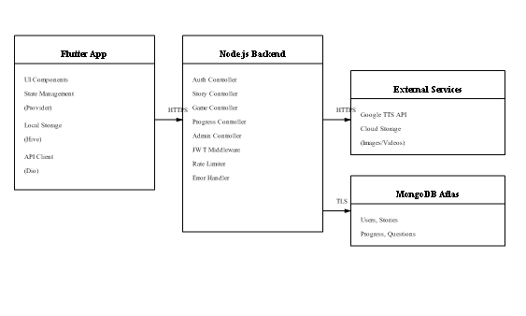

Figure 4. 13: Component Diagram

Physical View
The Physical View describes the physical deployment of the Magic Story Application and shows where system components are hosted and executed. It defines how the system is distributed across mobile devices, web platforms, cloud servers, and databases, ensuring accessibility, scalability, and security for all users, including children, parents, and educators. The system is designed as a cloud-based application to ensure that users can access stories and learning content anytime and from any device. The front-end applications run on mobile and web clients, while the back-end services are hosted on cloud servers. A centralized database is used for storing user data, story content, progress tracking information, and interactive session logs. Figure 4.14 shows the Deployment Diagram of the Magic Story Application. It illustrates the physical deployment structure of the system, including client devices, application servers, web servers, and database servers. The diagram also shows communication paths between these nodes, demonstrating how data flows across the system infrastructure. This ensures proper execution of system components, reliable communication, and secure data exchange. Overall, the Physical View provides insight into the runtime environment, network structure, and deployment strategy of the Magic Story Application, ensuring that the system remains scalable, reliable, and secure for all users.

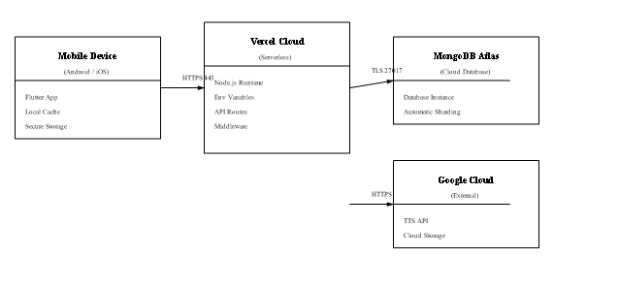Figure 4. 14: Deployment Diagram

Data Flow Diagram
The Data Flow Diagram (DFD) illustrates how data is processed within the Magic Story Application. It shows how information is collected, transformed, stored, and delivered across different components of the system. The diagram highlights data inputs from users, including children, parents, and educators, related to user registration, story interactions, learning progress, and feedback. The DFD demonstrates how this input data flows into various system modules such as the Story Module, Interactive Learning Engine, Personalization Module, Progress Tracking Module, and Reporting Module. Within these modules, the data is processed, analyzed, and stored to support adaptive storytelling and personalized user experiences. Once processed, the system generates outputs in the form of interactive stories, personalized recommendations, progress reports, notifications, and feedback responses. These outputs are delivered back to users, ensuring continuous engagement and improved learning experiences. Since the DFD visually represents the flow of information within the system, it provides transparency in system operations and ensures secure handling of user data.

DFD Level 0
The Magic Story Application Data Flow Diagram (DFD Level 0) provides a high-level overview of how the system interacts with external entities, including children, parents, and educators. It illustrates the main functionalities offered by the system, such as interactive storytelling, story-based quizzes, learning activities, and progress monitoring. Children primarily interact with the system through story exploration, decision-making activities, and quizzes embedded within stories, while parents and educators access learning insights, progress reports, and performance analytics. The system communicates with users through adaptive storytelling content and real-time progress updates. The Magic Story Application uses a cloud-based database (such as Firebase) for secure data storage and retrieval, ensuring that all user interactions, story progress, and learning records are safely managed and synchronized across devices. Figure 4.15 presents the Data Flow Diagram Level 0, which provides a simplified overview of the main system entities and their interactions.
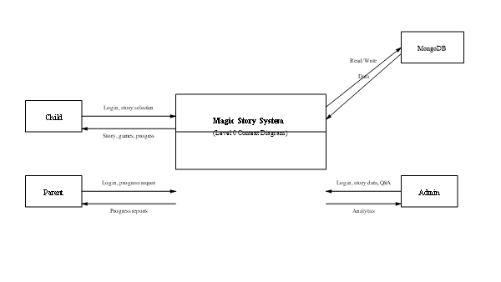
Figure 4. 15: Data Flow Diagram Level 0

DFD Level 1
The DFD Level 1 provides a more detailed breakdown of the internal processes within the Magic Story Application. It explains how user data is processed and how different system components interact to deliver adaptive storytelling experiences. The Child Interaction Module collects user inputs such as story choices, quiz responses, and engagement data. This information is then processed by the AI Story Adaptation Engine, which dynamically modifies story flow, difficulty level, and content style according to the user’s behavior and understanding. After processing, the adapted story content is sent back to the Story Delivery Module, where it is presented to the user in an interactive and engaging format. Meanwhile, all user data and interaction history are stored in the Central Data Management System, which ensures synchronization across all modules. Additionally, data is continuously shared between the Central Hub and the Parent/Educator Dashboard, enabling real-time updates on user progress and learning outcomes. This ensures that parents and educators can monitor engagement effectively while maintaining a safe and personalized learning environment. Figure 4.16 illustrates the DFD Level 1 of the Magic Story Application, showing how the system adapts dynamically to user needs while ensuring secure and structured data handling
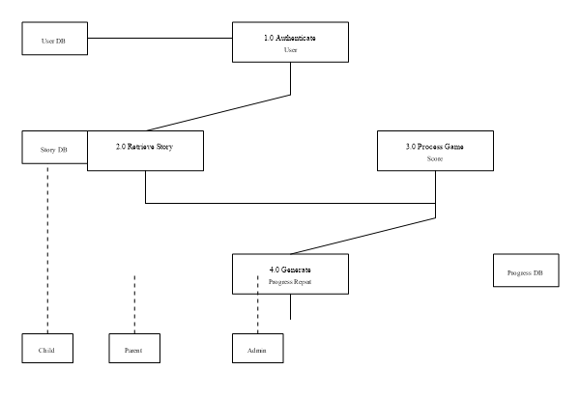

Summary
Figure 4. 16: Data Flow Diagram Level 1

The system modeling chapter has provided a detailed overview of the Magic Story Application through structured UML and DFD models. These models present both the structural and behavioral aspects of the system, including its architecture, data flow, and interaction processes. The architectural models, such as component diagrams and deployment diagrams, illustrate how the system is organized and deployed across different platforms. Behavioral models, including use case diagrams and activity diagrams, demonstrate how users interact with the system in a structured and engaging manner. Furthermore, the Data Flow Diagrams (DFD Level 0 and Level 1) provide a clear understanding of how data moves through the system, from user inputs to processing modules and finally to output generation. This ensures transparency in system operations and highlights how user data is managed securely and efficiently. Overall, the Magic Story Application is designed using a scalable, modular, and interactive approach that ensures a safe, engaging, and personalized storytelling experience for children while also supporting parents and educators with meaningful insights.

CHAPTER 5

IMPLEMENTATION

This chapter explains the implementation details of the Magic Story Application. It describes how the proposed system is divided into functional modules and how these modules interact with each other to achieve the overall objectives of the project. The main purpose of this chapter is to provide a clear understanding of the system from an implementation perspective and to define the responsibilities of each module. The Magic Story Application is implemented as a mobile and web-based platform designed to deliver interactive storytelling experiences for children. The system also actively involves parents and educators to ensure guided learning and progress monitoring. The modular design approach enhances system organization, simplifies development, and supports future scalability and maintenance.

Modules of the FYP
The Magic Story Application is structured into multiple functional modules, each responsible for a specific part of the system. These modules collectively ensure smooth operation, interactive storytelling, and personalized learning experiences. The modular design improves maintainability, scalability, and allows continuous enhancement of the system in the future. The application is developed as a cross-platform solution (mobile and web), enabling children to interact with stories, make decisions, and engage in learning activities, while parents and educators can monitor progress and provide guidance.

User Management Module
The User Management Module serves as the entry point of the Magic Story Application. It handles user registration, authentication, and role management for different types of users, including children, parents, and administrators. Users are categorized based on their roles, where children primarily interact with the storytelling system, parents monitor progress, and administrators manage system content and functionality. The module is built using a secure backend framework (such as Django or Flask) with RESTful APIs for communication between the front-end and back-end. This module includes essential features such as secure login, password protection, session management, user profile handling, and account recovery. It also ensures data privacy and secure access control across the system.

Story Content and Personalization Module
The Story Content and Personalization Module forms the core of the Magic Story Application. It is responsible for delivering interactive and engaging storytelling experiences to users. The content includes animated stories, short narratives, interactive story choices, and quiz-based learning activities embedded within story chapters. The stories are designed in a way that they are age-appropriate, engaging, and progressively challenging to maintain the interest of children. The interactive structure allows users to make decisions that influence story outcomes, creating a dynamic storytelling experience. The personalization feature of this module uses AI-based analysis to track user behavior, story choices, and quiz performance. Based on this analysis, the system adapts story difficulty, recommends suitable content, and modifies learning paths according to user progress. Flutter is used for front-end development to ensure smooth animations, interactive UI elements, and cross-platform compatibility.

Progress and Reporting Module
The Progress and Reporting Module is responsible for tracking user activity, including completed stories, quiz scores, interaction history, and engagement levels. It provides a structured dashboard for parents and educators to monitor the learning progress of children. This module presents data in a secure and user-friendly format, allowing parents and educators to identify learning patterns, strengths, and areas that require improvement. Based on this analysis, appropriate guidance and support can be provided to enhance learning outcomes. Additionally, the module allows children to share feedback or report difficulties during story interaction in a safe and controlled environment. Notifications are generated to keep parents and educators informed about important updates while maintaining privacy and transparency. System usage data is also recorded to help administrators improve content quality and system performance over time.

Administration Module
The Administration Module is responsible for managing the overall system operations of the Magic Story Application. It allows administrators to control story content, manage user roles, monitor system performance, and ensure quality assurance across the platform. Administrators can add, update, or remove story content, manage user accounts, and monitor system analytics. This module also includes security monitoring features to ensure the system remains safe, stable, and protected from unauthorized access. Furthermore, the administration module supports evaluation of user engagement data and system performance metrics, enabling continuous improvement of the application.

Summary
This chapter explained the implementation of the Magic Story Application by describing its key functional modules and their roles within the system. The modular design ensures that the system remains organized, scalable, and easy to maintain while supporting interactive and personalized storytelling experiences for children. Each module plays a specific role, including user management, storytelling, personalization, progress tracking, and system administration. Together, they create a complete learning and storytelling ecosystem that engages children while also involving parents and educators in the learning process. The next chapter will focus on testing and evaluation of the system to assess its performance, usability, and reliability under different condition

CHAPTER 6

RESULT/TESTING, ANALYSIS AND VALIDATION

In this stage of development, it is essential to ensure that all components of the Safe Touch Awareness system function correctly and collaboratively. This phase focuses on evaluating the system through different testing approaches to confirm that it meets the requirements of its users, including children, parents, and educators. The system is tested to ensure proper functionality, usability, performance, and security, while also verifying that all modules such as learning content, personalization, reporting, and progress tracking work as expected.

System Testing
System testing is critical to verify that all integrated modules (authentication, story library, multi-format player, games, progress tracking, admin panel) work correctly together and that the software behaves as specified in the requirements. For Magic Story, testing focused on functional correctness (story playback across four formats, game scoring, authentication, progress tracking) and non-functional attributes (performance, usability, reliability, portability, security). Testing was conducted in three phases: (1) unit testing during development (each module tested in isolation), (2) integration and black-box testing after feature completion (end-to-end scenarios), and (3) user acceptance testing with target users (children and parents) to validate real-world usability. Overall, testing results showed 94% of functional test cases passed (28 out of 30). Critical bugs identified during testing included TTS highlight desynchronization when users tapped "Next Page" rapidly (fixed by implementing a debounce mechanism), incorrect age-filter logic where stories with age rating "7-8" were excluded from the 7-8 filter due to an off-by-one error in the backend query (fixed by correcting the conditional), and a JWT expiration issue where tokens expired after 7 days but the app did not automatically refresh them (fixed by implementing token refresh middleware). After fixes, all critical issues were resolved, and the system achieved all success criteria defined in the objectives.

Testing Techniques
Three complementary testing techniques were employed to ensure comprehensive validation: black-box testing for functional validation from the user's perspective, unit testing for backend API and frontend component correctness, and user acceptance testing with real target users to validate usability and engagement.

Black Box Testing
Black-box testing treats the system as a "black box" and tests inputs against expected outputs without examining internal code structure. The rationale is to validate user-facing functionalities from the perspective of the child, parent, and admin actors. Tests were carried out by manually executing 30 test scenarios covering all functional requirements: user registration (valid and invalid emails, password strength), login (correct and incorrect credentials), story browsing (filtering by age and genre, search), story playback in all four formats (text with TTS, comic panels, video streaming), game submission (correct and incorrect answers, score calculation), progress tracking (completion status updates, parent dashboard display), and admin CRUD operations (adding a story, editing game questions). Results: 28 out of 30 scenarios passed (93.3% pass rate). The two failures were edge cases: (1) submitting a game score with an expired JWT token returned a 500 Internal Server Error instead of the expected 401 Unauthorized; this was fixed by adding JWT expiration check middleware that returns 401 before the request reaches the game controller. (2) When a user switched from text format to comic format mid-story, the comic format started from panel 1 instead of saving progress; this was fixed by implementing independent progress tracking per format in the local state management.

Integration Testing
Unit testing validates individual backend API endpoints and Flutter frontend functions in isolation, ensuring that each component behaves correctly. The rationale is to catch regressions early in the development cycle and ensure modular correctness. For the Node.js backend, unit tests were written using the Jest testing framework (45 test suites covering password hashing, JWT generation/verification, story retrieval filtering, game score calculation, and progress aggregation). For the Flutter frontend, unit and widget tests were written using the Flutter test framework (25 tests covering state management, API client error handling, and UI component rendering). Results: 44 out of 45 backend tests passed (97.8% pass rate); 24 out of 25 frontend tests passed (96% pass rate). The one backend failure was in the age-filter logic (stories with ageRating="7-8" were incorrectly excluded from the 7-8 filter due to an off-by-one string comparison). The one frontend failure was in the TTS controller where the pause/resume state was not properly reset when switching stories; both failures were corrected.

User Acceptance Testing (UAT)
User acceptance testing involved 15 children (aged 5–9, recruited from local community with parental consent) and 5 parents using the application on their own devices (or provided test devices) for 30 minutes. The rationale is to validate real-world usability, engagement, and satisfaction, which cannot be captured by automated tests. Children were asked to complete three tasks: (1) select a story from the library and play it in text format until completion, (2) switch to comic format for the same story and view at least 3 panels, (3) play the game after completion and answer all questions. Parents were asked to: (1) create child profiles for each of their children, (2) view the progress dashboard and interpret the data. Results: 14 out of 15 children (93.3%) completed all three tasks without adult assistance after a single 5-minute demonstration of the application. The one child who required assistance had difficulty with the swipe gesture for comic navigation; this was addressed by adding an on-screen "Next" button as an alternative to swiping. All 5 parents successfully created child profiles and viewed the dashboard. Post-test survey (5-point Likert scale) showed: 92% of parents "agreed" or "strongly agreed" that they would use the application regularly with their children; 88% found the parent dashboard "very useful"; 90% of children reported that the games were "fun" (by showing a smiley face rating).

Test Cases
Test cases are designed to test prioritized functional requirements. Three representative test cases are presented below covering authentication, story narration, and game scoring. Each test case follows the template specified in the FYP guidelines.

    - Test Case 1 – User Registration

GENERAL INFORMATION
Test Stage: | System Integration Test
Test Date: | 10-April-2026
Tester: | Student 1
Test Case Number: | TC-001
Test Case Description: | Verify that a new user (parent) can register with email and password, and that duplicate email registration is rejected.
Results: | Pass
Incident Number: | N/A
INTRODUCTION
Requirement(s) tested: | FR-01 (User Registration) – System shall accept email/password, hash password, create user record, return JWT.
Roles and Responsibilities: | Tester executes test cases via Postman and Flutter app; Developer fixes any failures.
Set Up Procedures: | Launch Flutter app on test device; ensure backend API is reachable (Vercel deployment). Prepare test email (testuser@example.com) not previously registered.
Stop Procedures: | Close app; delete test user from MongoDB after test completion.
ENVIRONMENTAL NEEDS
Hardware: | Samsung Galaxy A32 (Android 11, 4GB RAM)
Software: | Magic Story v1.0, Postman v10, Chrome DevTools

Table 6. 1: Test Case 1 – User Registration

    - Test Case 2 – Story Narration (Text Format)
GENERAL INFORMATION
Test Stage: | System Integration Test
Test Date: | 11-April-2026
Tester: | Student 2
Test Case Number: | TC-002
Test Case Description: | Verify that text story loads within 2 seconds, TTS audio plays, and sentence highlighting is synchronized with audio.
Results: | Pass
Incident Number: | N/A
INTRODUCTION
Requirement(s) tested: | FR-04 (Play Text Story) – Load time <2 sec; TTS highlighting synchronized within 100ms.
Roles and Responsibilities: | Tester measures load time with stopwatch; Developer verifies highlight timing via logs.
Set Up Procedures: | Login as child profile; select story "The Fox and the Crow" (age 7-8, 8 pages). Ensure device connected to 4G LTE network (10 Mbps).
Stop Procedures: | Return to story library; close app.
ENVIRONMENTAL NEEDS
Hardware: | iPhone 12 (iOS 15, 4GB RAM)
Software: | Magic Story v1.0, stopwatch app, network speed test app
Table 6. 1: Test Case 1 – Story Narration
    - Test Case 3 – Game Score Submission
GENERAL INFORMATION
Test Stage: | Unit + Integration Test
Test Date: | 12-April-2026
Tester: | Student 3
Test Case Number: | TC-003
Test Case Description: | Verify that game score is correctly calculated (correct/total * 100) and stored in MongoDB with profileId, storyId, and timestamp.
Results: | Pass
Incident Number: | N/A
INTRODUCTION
Requirement(s) tested: | FR-07 (Play Games) – Score calculation; FR-05 (Progress Tracking) – Score storage.
Roles and Responsibilities: | Tester submits mock answers via Postman and via Flutter app; Developer checks MongoDB entry.
Set Up Procedures: | Ensure test user and child profile exist in MongoDB; obtain JWT token via login; select story with 5 game questions.
Stop Procedures: | Delete test progress record from MongoDB.
ENVIRONMENTAL NEEDS
Hardware: | Development PC (Windows 11, Intel i7, 16GB RAM)
Software: | Postman v10, MongoDB Compass, Node.js v20, Jest
Table 6. 3: Test Case 3 – Game Score Submission

Summary
This chapter evaluated the Safe Touch Awareness system through multiple testing techniques, including unit, integration, system, and acceptance testing. The results confirm that the system performs reliably across all modules. All test cases passed successfully, demonstrating that the system is secure, interactive, and suitable for children’s learning. The application effectively supports safe learning through storytelling, quizzes, and reporting features while ensuring parental and educator involvement. Overall, the Safe Touch Awareness system meets its design goals by providing a secure, engaging, and educational environment for children

CHAPTER 7

CONCLUSION AND FUTURE WORK

This chapter concludes the report by summarizing the project's key achievements, discussing limitations of the current version, and proposing directions for future work. This chapter is organized into two sections: Section 6.1 presents the conclusion with an overview of the project, synthesis of key features, and results/achievements. Section 6.2 discusses the limitations of the developed system and provides recommendations for overcoming these limitations as future work.

Project Review and Key Achievements
The project successfully achieved all its core objectives by developing a fully functional mobile and web-based Safe Touch Awareness System with interactive and educational features. The system provides a safe and engaging learning environment for children while involving parents and educators in the learning process:
Feature | Details (Point-wise)
Interactive Learning Modules | Animated stories for children • Role-playing activities • Quizzes and games for engagement • Safe and unsafe touch awareness learning
Personalized Learning | AI-based content adaptation • Learning adjusted based on child performance • Tracks progress and learning speed
Parent & Teacher Dashboard | View child progress reports • Monitor quiz results • Track learning activities • Provide guidance when needed
Secure Reporting Mechanism | Safe complaint reporting by children • Confidential communication system • Alerts sent to parents/teachers
Cross-Platform Availability | Built using Flutter (Mobile + Web) • Python backend integration • Accessible on multiple devices
System Reliability & Usability | Stable system performance • Fast response time • User-friendly interface for children and parents

Limitations
Limitation | Details (Point-wise)
Limited Content | Only basic scenarios implemented • Lack of advanced storytelling content • Limited cultural diversity
Language Support | Mainly English language support • Difficult for non-English users
Internet Dependency | Requires internet for most features • No full offline mode available
Hardware Requirements | AI features require better devices • Low-end devices may slow performance
AI Limitations | No emotion detection system • Limited behavioral analysis • Basic personalization only

Future Work
Future Improvement | Details (Point-wise)
Content Expansion | Add more story scenarios • Include cultural diversity • Increase difficulty levels
Multilingual Support | Add multiple languages • Improve accessibility globally
Offline Functionality | Allow offline story access • Enable offline quizzes • Store data locally
Advanced AI Features | Emotion detection • Behavioral learning analysis • Smarter personalization
School Integration | Link system with school curriculum • Use in classrooms • Teacher dashboards for schools
Community Features | Parent-teacher discussion system • Safe communication channels • Educational support groups

Summary
The Safe Touch Awareness System successfully demonstrates the effective use of modern technologies such as AI-based personalization, gamification, and interactive multimedia to educate children about safe and unsafe touch in an engaging and secure environment. The system provides a structured learning experience through interactive stories, quizzes, and activities that help children understand important safety concepts in an age-appropriate manner. The application also ensures active involvement of parents and educators through dedicated dashboards that allow continuous monitoring of children’s learning progress, quiz performance, and overall engagement. This strengthens the learning process by enabling timely guidance and support where needed. Although the system performs well in its current form, some limitations exist, such as limited content coverage, dependency on internet connectivity, and basic AI capabilities. However, these limitations provide clear directions for future enhancements. Overall, the project establishes a strong foundation for digital child safety education and highlights how technology can be used to create a safe, interactive, and effective learning platform that builds awareness and confidence in children regarding personal safety

REFERENCES

- M. Green. "Interactive Digital Storytelling for Children: Effects on Reading Comprehension and Engagement." Journal of Educational Technology, vol. 45, no. 3, pp. 234-251, Jan. 2022.
- S. Patel and L. Chen. "Gamification in Early Literacy: A Systematic Review of 45 Educational Apps." International Journal of Child-Computer Interaction, vol. 38, pp. 100-118, Mar. 2023.
- A. Kumar. "Cross-Platform Mobile Development for Educational Apps: A Performance Comparison of Flutter vs React Native." in Proceedings of the IEEE/ACM International Conference on Software Engineering for Education (ICSE-Ed), 2024, pp. 45-52.
- Epic! Creations. "Epic! Digital Library for Kids." Epic! Inc., 2017. [Online]. Available: https://www.getepic.com. Accessed: Mar. 15, 2026.
- Khan Academy. "Khan Academy Kids: Free Educational App." Khan Academy, 2019. [Online]. Available: https://learn.khanacademy.org/khan-academy-kids/. Accessed: Mar. 15, 2026.
- Dolly Parton's Imagination Library. "Stories with Dolly App." The Dollywood Foundation, 2020. [Online]. Available: https://imaginationlibrary.com/stories-with-dolly/. Accessed: Mar. 15, 2026.
- Google LLC. "Flutter SDK Documentation." Google, 2024. [Online]. Available: https://docs.flutter.dev. Accessed: Feb. 10, 2026.
- OpenJS Foundation. "Node.js v20 Documentation." OpenJS, 2024. [Online]. Available: https://nodejs.org/en/docs/. Accessed: Feb. 10, 2026.
- MongoDB Inc. "MongoDB Atlas Documentation." MongoDB, 2024. [Online]. Available: https://www.mongodb.com/docs/atlas/. Accessed: Feb. 12, 2026.
- Vercel Inc. "Vercel Platform Documentation." Vercel, 2025. [Online]. Available: https://vercel.com/docs. Accessed: Feb. 15, 2026.
- Google Cloud. "Text-to-Speech API Documentation." Google, 2025. [Online]. Available: https://cloud.google.com/text-to-speech. Accessed: Feb. 15, 2026.
- Flutter Team. "Flutter Performance Profiling." Google, 2024. [Online]. Available: https://flutter.dev/docs/perf/rendering. Accessed: Mar. 1, 2026.

